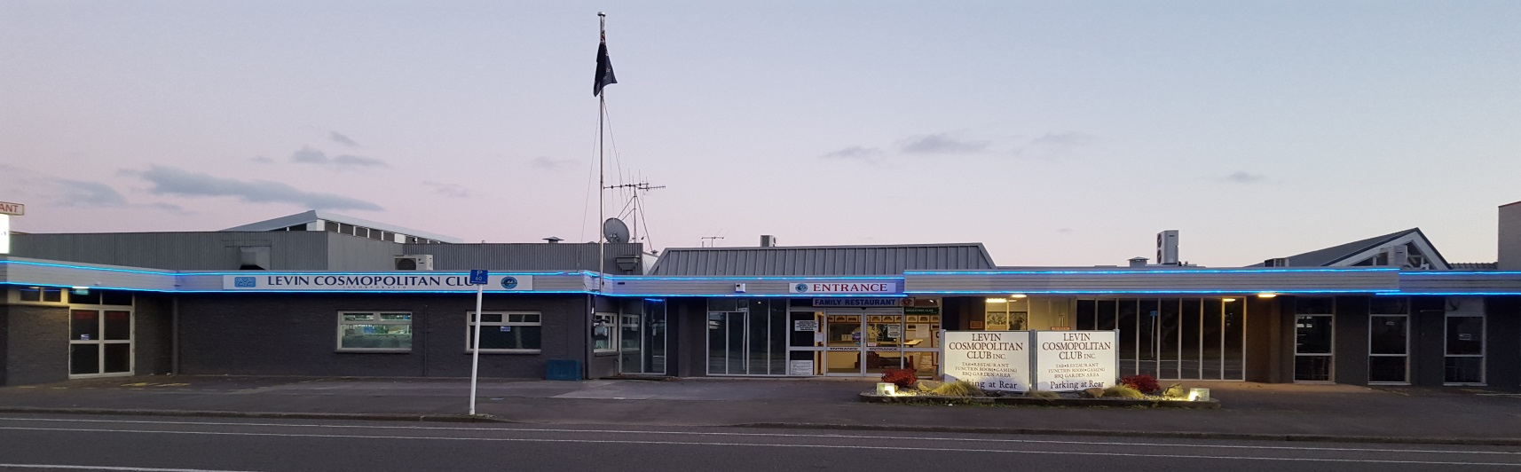
July 2019 Newsletter
Levin Cosmopolitan Club Inc
Hello everyone
July is almost over already – wow! Where did this month go?

I must say that when coming into the Club just how immaculate and well presented the place always is, irrespective of the previous day’s festivities, meetings or whatever. So a big big thanks from everyone to the staff responsible for our cleaning duties – Krishla & Carolin, and also to the people keeping the grounds tidy – Don and his team. The quality and commitment of your work efforts is truly appreciated by all.

With some really strong trading and increased patronage, especially over the last 3-4 months as our marketing efforts have kicked in, we will see the Club again post a surplus this year. This outcome will put us in a good position heading forward into our 120th year next year and will enable us to continue with upgrades and maintenance projects without borrowing.

Everyone should feel proud of being a member of the Levin Cosmopolitan Club.

Happy Clubbing
Notice
During August some planned changes will occur in the main Bar and Pokie room.

New carpet tiles will be fitted in the members lounge bar which will occur over three successive Mondays – the 5th, 12th & 19th August.

Also on Monday 12th August a “makeover” of the Pokie room has been booked in.

We have planned for a minimum of disruption to members. Your understanding and patience is politely requested.

Updated Website & New Facebook

Please take note we have revamped our website – it still has the same domain name:
www.levincossieclub.co.nz
Please check it out, but note there is still some work in progress.

Also check out our new Levin Cossie Club Facebook page - add us as a friend to keep up to date on what’s happening at the Club.

We are also texting our members now with Restaurant Specials and info regarding our weekly member draws etc, so if you haven’t had a text check with the office to ensure we have your cell number listed.

On the other hand if you are receiving the texts and don’t want them, please reply to the text with STOP to opt out – or let the office know .

Club Shirts - $25.00

We have Cossie Club shirts available for purchase at $25.00. They have the Club Logo on them and are really nice quality. If you wish to purchase or have a look they are available from the Office.
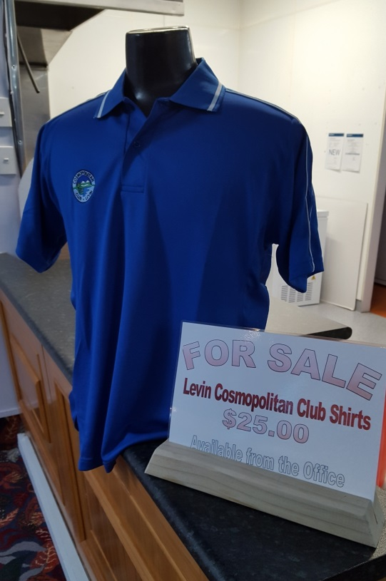

Clay Target Adjunct

Any shooters or club members that tick the Clay Target box who want to be involved please contact George Harper or Blue Taylor and we will help you get started at our Horowhenua Club grounds. You will need a gun or firearms licence and other gear which we will advise you of.

Cheers
Blue Taylor

Open Cue Sports Adjunct

Our Club Champs Open Singles took place on 14th July with a high quality field of 36 players. The eventual winner was Steve Pemberton who never lost a match all day.
Runner up position went to Ryan Gardiner who also played well to reach the final.

Sun – 11 August is our next Tournament date with the Mike Doyle Memorial - Open Singles taking place. Registration for this event is from 9am to 9-30am.

Annual General Meeting (AGM)

Cue Sports Adjunct AGM was held in the Hudson Room on Sunday 14th July at
9-45am.

The duly elected committee is as follows:
President: Dave Morris
Secretary: Pam Morris
Treasurer: John Beattie

Committee Members:
Don Hughes, Maggie Cadman, Warren Laing, Rob Anderson.

Business House League

Thirteen weeks gone and we have now split into Top 7 and Bottom 7 separate sections. The two sections will play off for their respective trophies over two full rounds, with the first round beginning on the 1st August.

Club shirts are selling well, as they should at only $25.00 each, so join in, buy a shirt and wear it proudly when you compete.

Lots of luck
Dave Morris
Seniors Adjunct

July 10th we had a visit by Palmerston North Cossie to play 8-Ball and Bowls.
The day was a success from our sports teams perspective but also a catering success story with a nice spread being put on by the club once again for our visitors.

July 25th it was our turn to visit Porirua to defend the Kiwi Trophy. I’m sad to say we couldn’t rescue the little Kiwi from his dismal surroundings and bring him home as we were beaten in all three of the sports we played. He will have to wait until next year now the poor little fellow.

Our bus driver, Harold, must have been feeling a little chilly as the heat in the bus was turned up to furnace like proportions. He eventually turned it down as some of the ladies were beginning to disrobe, and honestly, we didn’t want that to continue.

Don’t forget Subs are due by the 31st July. Pay your Club dues first then your Seniors Sub.

August 12th to 14th are the dates for the Annual Conference and Club Sports Tournament at Waitara this year. Still space available for members to go if you contact Fred or Annette.

Don’t forget, our Seniors AGM is scheduled for Wednesday 11th September at 1-30pm.
We still need committee members so don’t be reticent in coming forward and putting your name up if you feel you could help or make a difference in any way. Please remember you need to show your current Seniors membership card when attending the AGM..

Good Health
Dave Morris

Remembrance

It is with great sadness that we have to farewell the following members:

Mei Vailima Member since April 2018
Trevor Harris Member since September 1986
Charles (Merv) Smith Member since January 1994

Our thoughts and condolences go out to their family and friends.

Up Coming Events

Saturday 17th August Karaoke with Hendrix
Sunday 18th August Opportunity Knocks Country Club 1pm – 5pm
Sunday 25th August Country & Variety Music Club 1pm – 5pm
Saturday 31st August Live Band: “Just Us Duo”
Wednesday 11th Sept Senior Members Club AGM 1.30pm
Sunday 15th September Opportunity Knocks Country Club 1pm – 5pm
Sunday 29th August Country & Variety Music Club 1pm – 5pm

