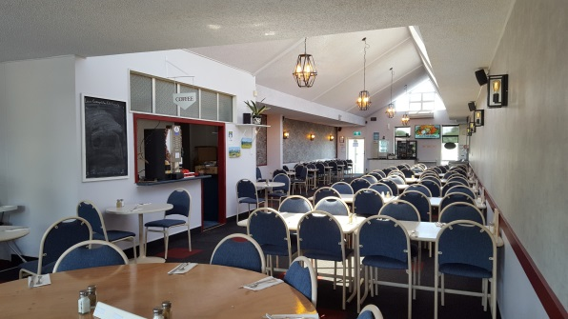
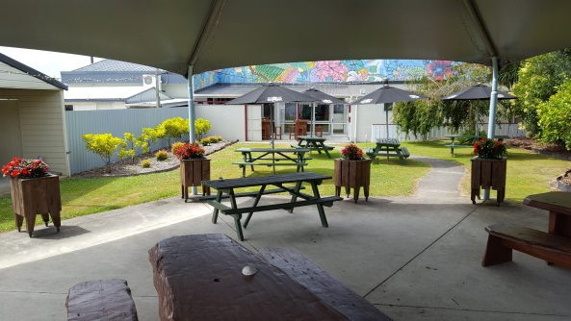
Levin Cosmopolitan Club Inc

January 2019 Newsletter

Hello Everyone, we trust we all have had a pleasant Christmas/New Year period with the weather mostly playing ball, and now we are all looking towards a happy and healthy 2019.

Our fully air-conditioned Clubhouse has been much appreciated by those in attendance, especially over the recent steamy hot days. It is nice to see so many members and their guests quietly relaxing, sometimes imbibing or dining at the “Hot Spot” or the Tararua Restaurant and watching sports on any of the many TV screens – cricket, tennis, snooker, football and horse/greyhound racing etc. Fantastic to see.

It is very gratifying to report to members, the LCC received very pleasing feedback and accolades in the Electra Business Awards 2018 – Customer Choice Category and we quote:

Average scores (out of 10 with 1 being ‘poor/not at all likely’ to 10 ‘certainly/truly outstanding’)

How likely they would recommend your business to a friend or colleague: 9.9
The Staff: 9.2
The quality of the service: 9.3
Overall experience: 9.6

Age Friendly Results:
Feeling welcomed as a valued older person: 9.9
Catering for my physical needs & comfort: 9.9

Voters Comments:
Below is a list of most of the comments made by voters when voting.

- A very warm welcoming venue to use. Highly recommend new members to join this club
- A very well run Club

- The staff and committee always made you feel special and go above and beyond to ensure everyone is happy and for fresh ideas on what things you would like to be included in the club
- Warm welcome all the time
- I have been a member of this club for more than 13 years and find it’s a wonderful place for entertainment and fellowship
- Great staff, fantastic food, a great environment and plenty of activities and events to get involved with
- I have been a member of the Club for 44 years and I still go there for dinner with my Grandchildren on special occasions such as their birthdays
- This is one of the best places to meet and eat in Levin. Staff speak to you and know you by name
- The cossie club is a great place to socialise
- You guys are easily the most accommodating in Levin
- Very well appointed, something for all age groups. Delicious food plus great bar snacks. A place to make new friends and catch up with old friends
- Great place, staff great. Friendship is paramount within the club. Plenty of options provided by staff and management
- This club is very comfortable and caters for all people. Great restaurant.

Our business does depend a lot upon patronage, we are always encouraging members to use our Club facilities, so it is so satisfying to receive such great feedback.

Our annual new members Open Day will be held this Waitangi Day, Wednesday 6th February 10am to 3pm.

This is an opportunity to those who would like to look over our Club, and talk with staff and members about joining up.

Please bring along or invite your friends, relatives and neighbours who you would also like to see as members, to come on down. Everyone joining on the day will receive a complimentary “Hot Spot” meal voucher when they pick up their new membership card.

In our gaming room punters will notice we have purchased new improved designer stools for their comfort, and a new gaming machine has also been purchased and installed. Happy Gaming!!

From the Treasurer’s desk, he reports the first five months of Club trading to 31/12/18 is now close to budget as we had experienced some months of “mediocre” trading. There are underlying cost pressures emerging and this is not only internal (bar, insurance, labour etc) but, more particularly, from external factors such as markedly increased charge-out labour costs for service people and tradies – some have jumped from $45 per hour to $70 per hour and more!

The mandate the Treasurer and Executive Committee operate under in the financial management of the Club is one of remaining mortgage free (which is proving itself time and time again to be the only sensible business strategy for Clubs that want to survive).
To maintain this position it is critical the Club maintains good levels of working capital so we can always keep the Club in the current condition that we have all become accustomed to.

While previous brewery price increases have been absorbed by the Club for almost six months, now some of our prices will need to increase so to maintain our margin and to meet all of our obligations and the mortgage free strategy. Members of course will still earn the same percentage loyalty points on their food and beverage purchases on presentation of your membership card at time of purchase. The Treasurer has said the increases will be as low as is practical. Sorry!

Recipients of 2018 Tertiary & Trade Grants:

We are thrilled to advise the following people were awarded our 2018 Tertiary & Trade Grants:

Billeigh Dawson-Hughes
Taitiana Taukiri
Josh Madgwick
Liam McLeavey
Sophie Simons Nyssen

Well done, and all the best with your future endeavours.

Chiller Trailer

Please be aware that we have sold our chiller trailer due to high maintenance costs.
It has been purchased by Levin Party Hire in Prouse Street.

All bookings we already had in our diary are being honoured by Levin Party Hire, and if you wish to hire the trailer in future, please show them your membership card and you will receive 25% discount on your booking.
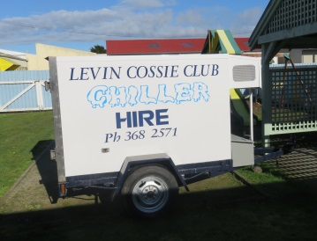

Member Specials

As you will be aware, the price of Tap beer will increase from the 3rd February 2019. We have however been able to negotiate with the breweries some specials for our members.
SUPER WEEKEND SPECIAL
SATURDAYS & SUNDAYS ONLY

TUI – EXPORT GOLD – DB DRAUGHT & AMSTEL JUGS
$9.50
EVERYDAY SPECIALS

COSSIE BREW &
Thomas Edison Low Alcohol 2.5
$10.50 JUGS
$5.30 HANDLES

TIGER STUBBIES
$6.00 each
Or 4 for $20.00

Seniors Adjunct

The first club day for 2019 was on Jan-16 which included a successful start to Housie. The Indoor Bowls and 8-Ball teams also began their New Year with members turning out in good numbers.

Upcoming Events:

A Non-Wednesday trip to Te Papa is being planned to view the Terracotta Warriors.
A trip on Wed-20-Feb to Kaitoke Gardens and then Lake Ferry for lunch is in the offering. Please see the notice board for details and to sign up for these trips.

The Seniors Adjunct Barbeque is planned for 12 Noon on Wed 30th Jan at the Cossie Club. Tickets are available now at a cost of $15 per head. Don’t miss this one.

Good Health and Happy New Year
Dave Morris
Open Cue Sports Adjunct

Happy New Year to all our Cue Sports Adjunct members.

I begin with the sad news that Lynn Scott (Scotty) passed away on 4-Jan-2019.
The pool rooms at Upper Hutt, Petone and Levin will seem a lot gloomier without Scotty’s smiling face, sparkling wit and cheeky irreverent humour. RIP Scotty.

Our Adjunct club nights continue on Thursdays from 7-30pm and seem to attract a good following of keen 8-ball enthusiasts. The Pyramid Challenge Ladder is still in play and changes are occurring all over the place and not just at the top.

Upcoming tournaments are listed on the notice board and include the “John King” Masters Pairs tournament on 23 and 24-Feb at Waikanae. Entries for this close on
14-Feb, so if you haven’t already registered you had better do so or you’ll miss out.

Pool Cue Storage Cases

The metal cue case storage area at the eastern end of the club holds a lot of cue cases that are no longer being used. Owners have either passed away or are no longer club members. Either way, we need to identify these cases with the object of re-circulating the unidentified ones. So with that in mind please put your name on your own case by 15-Feb. and if you can help to identify any of the other owners, please do so by letting me know.

Lots of luck for the New Year
Dave Morris

Clay Target Adjunct

Any shooters or club members that tick the Clay Target box who want to be involved please contact George Harper or Blue Taylor and we will help you get started at our Horowhenua Club grounds. You will need a gun or firearms licence and other gear which we will advise you of.

Cheers
Blue Taylor

Remembrance

It is with great sadness that we have had to farewell the following members this month:

Lynn (Scotty) Scott Member since October 2007
Dan Inglis Member since February 2017
Diane Te Whaiti Member since February 2017

Our thoughts and condolences go out to their families and friends.

Personal Hygiene

With the hot weather already here, and hotter weather looming, we ask our members to be mindful of their personal hygiene.

Up Coming Events

Wednesday 6th February Club Open Day 10am – 3pm
Wednesday 6th February Freedom Express 11.30am – 3.30pm
Wednesday 6th February Live with Sofia Tavlik – 6.30pm ($20 per ticket)
Saturday 9th February Karaoke with Hendrix
Sunday 17th February Opportunity Knocks Country Club 1pm – 5pm
Saturday 23rd February Jukebox
Sunday 24th February Country & Variety Music Club 1pm – 5pm $4 entry

