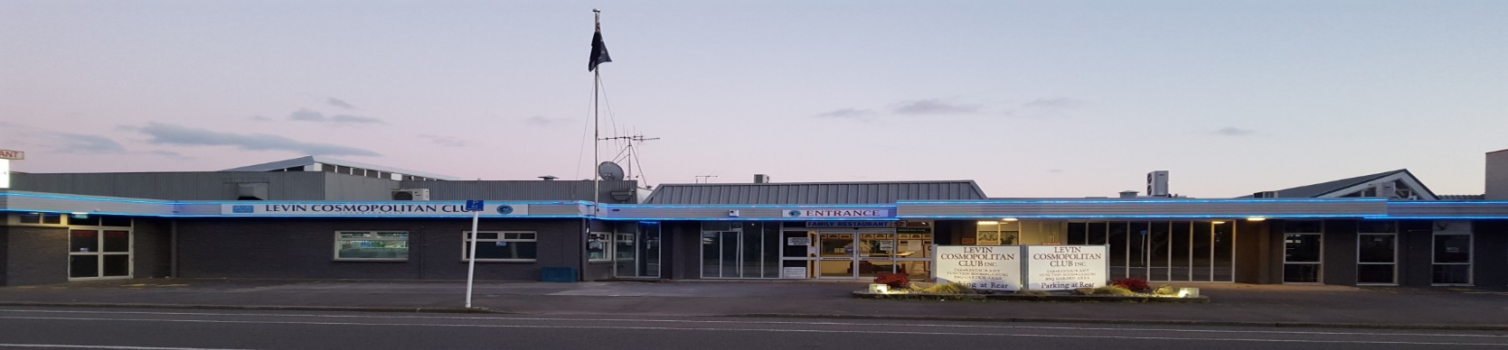
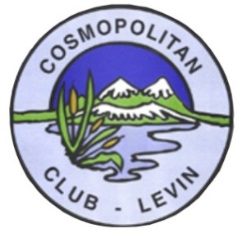
October 2019 Newsletter
Levin Cosmopolitan Club Inc

Hello everyone and warm “sunny” spring wishes to all!

Our AGM on 13th October was another successful day at the Club. The Treasurer reported on an outstanding trading and profitable performance for the year ended 31/07/19 of $414,000 and a strong balance sheet including cash balances of $325,000 and investments of another $500,000. The full annual report can be viewed on our webpage. Some hard copies are also still available from the office.

John Martin and Colin Lawrie were the successful candidates for the Main Committee. Bruce McCarrison and Mark Verran are our President and Vice President respectively.
We also had two recipients for Life Membership: Steve Pemberton & Paul Pearce.

New lunch time Restaurant opening hours Tuesday to Saturday is 11am to 2pm daily.
So enjoy this earlier opening time for a quick snack or leisurely brunch. Details of further special discounts are later in the newsletter and are available also to the public but with no bar service because of licensing laws.

New members furniture for the Main Bar and Restaurant is due mid November. A last reminder to members of the opportunity to place your order on the main noticeboard for the remaining so far unsold redundant furniture.

A brand new 82” Big Screen TV has been purchased and installed in the main bar, replacing the old tired projector/screen equipment. Come down, be prepared to be impressed.

Repairs and painting of the club roof is now underway. A small section will be totally replaced by local tradespeople when weather conditions permit, probably December/January timing.

Labour Weekend 8 Ball tournament is now very close to a full field. Good luck everyone!

Tuesday November 5th is Melbourne Club Day at the Club including Fashion in the Field for Ladies and Gents. A great Dress Up day opportunity for all.
Cheers and Happy Clubbing to everyone.
Remembrance

It is with great sadness that we farewell the following members:

Bob Millard Member since June 1980
Brian Davis Member since February 2016
John Collins Member since October 2015

Our thoughts and condolences go out to their families and friends.

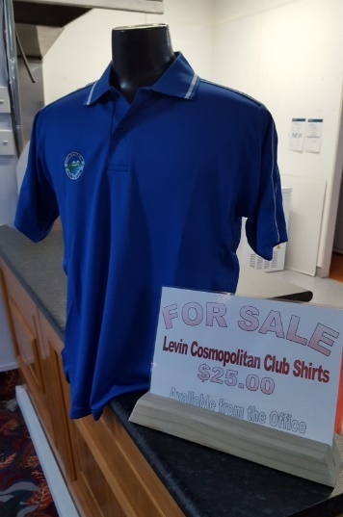
Club Shirts - $25.00

We have Cossie Club shirts available for purchase at $25.00. They have the Club Logo on them and are really nice quality. If you wish to purchase, or have a look, they are available from the Office.

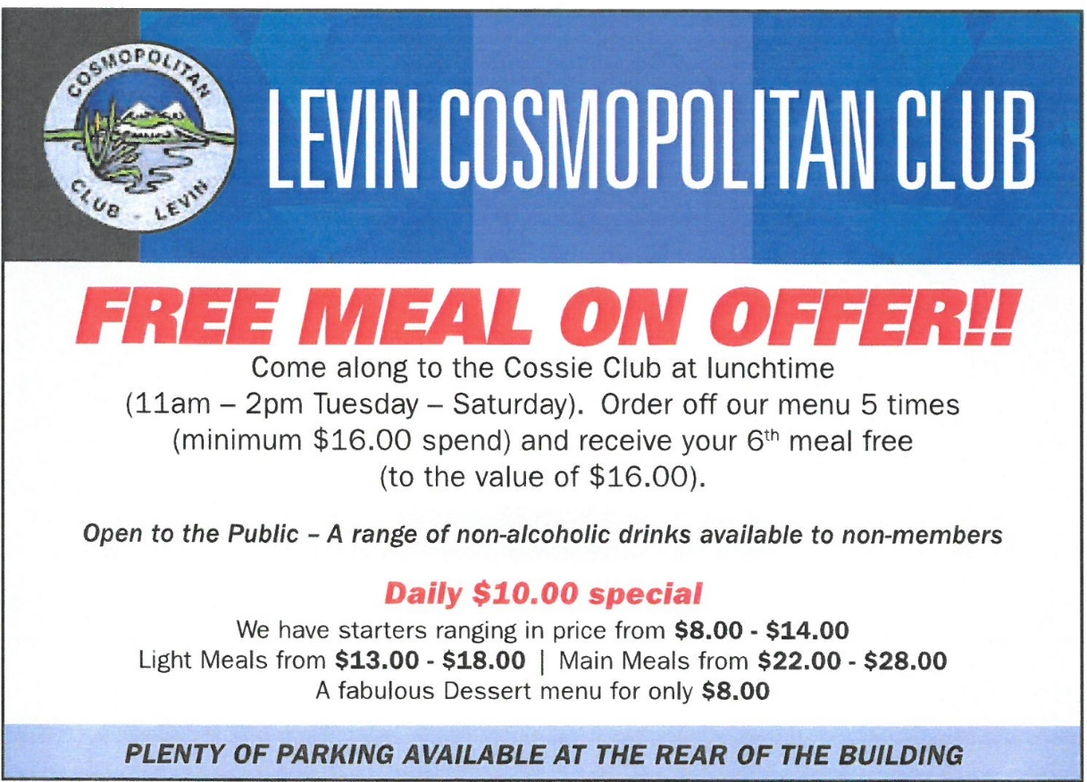
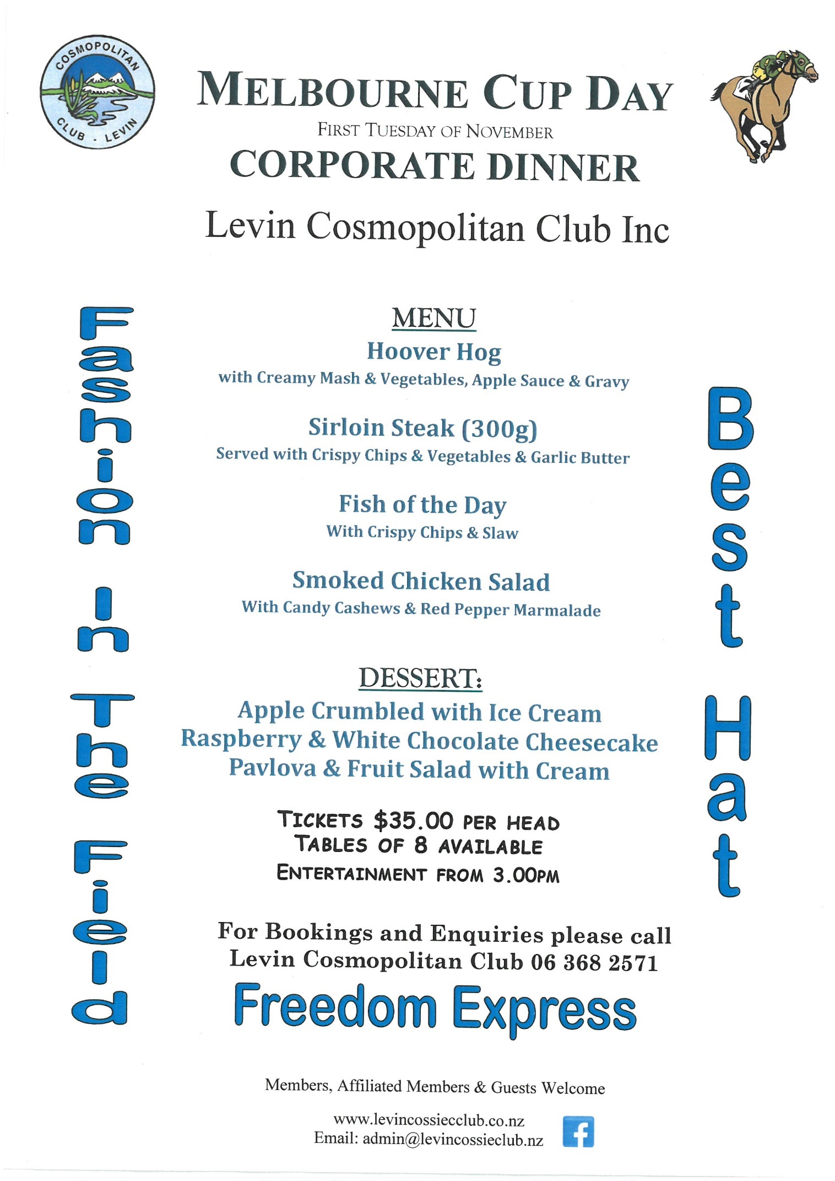

Open Cue Sports Adjunct

The recent period of Sept/Oct has been a busy one for 8-Ball players in Levin.
In our local Club Champs we held the Open Pairs and Ladies Singles tournaments.
Open Pairs
Winners: Steve Pemberton and Scott Woodley
Runners Up: Scott McLeod and Tony Jones
Ladies Singles
Winner: Leanne McDermott
Runner Up: Raewyn Jones

Inter Adjunct Challenge (Lynn Scott Memorial Trophy)
Levin Vs Petone
Winners: Levin Cossie Club
This was the inaugural year of an annual event planned between Levin and Petone adjuncts to commemorate Scotty’s enthusiasm for the game and the respect held for him by members of both these clubs. It was a hugely successful day which included a barbeque lunch and hard fought 8-Ball matches enjoyed by everyone.
Results: Levin 123 Petone 81
Miniature trophies were presented to the “Top Gun” in each team and these were won by the players in each team who never lost a game all day:
Phil Bucknall for Levin and Chris Baker for Petone.
A beautiful Cup (donated by PWMC) was presented to the winning team by Kathryn Scott.
There was a novelty trophy played for after the main event (one of Scotty’s old legs), this was also won by Levin 5-3.
A big thanks to all the helpers who gave up their time to make this a really enjoyable day.

Labour Weekend Tournament
This was played over 3 days from 26th to 28th Oct.
More on the results in next month’s newsletter.

Adjunct Notice Board
A schedule of LCC tournaments still to come in 2019 has been posted on our notice board and Facebook page, and this includes:

14th Nov Greg Canty Cup – Open 9-Ball singles
17th Nov Ladies Pairs and Ladies Drawn Pairs
21st Nov Vice Presidents Cup – Singles (Adjunct Members)
24th Nov Maurie Bang Cup - Mixed Pairs (One player only needs to be an LCC member)
28th Nov Presidents Cup – Drawn Pairs (Adjunct Members)

Lots of luck
Dave Morris

Levin and Petone players
All friends after the event
Winners of Novelty Trophy – Levin (Scotty's spare leg)

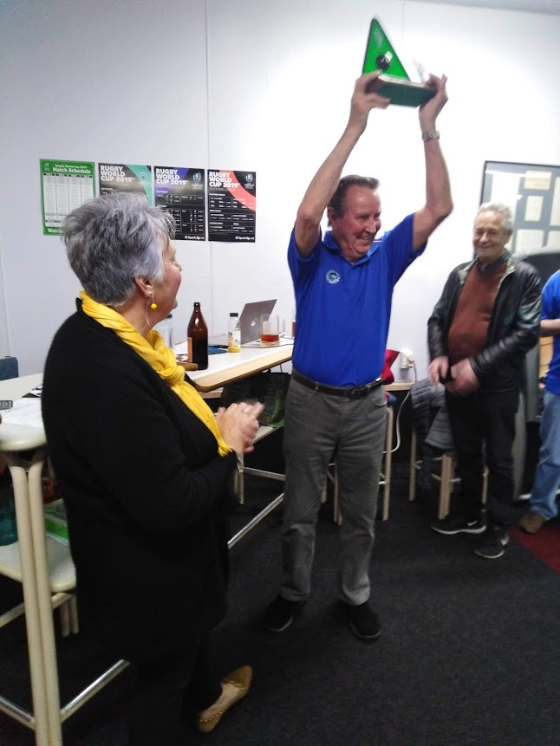
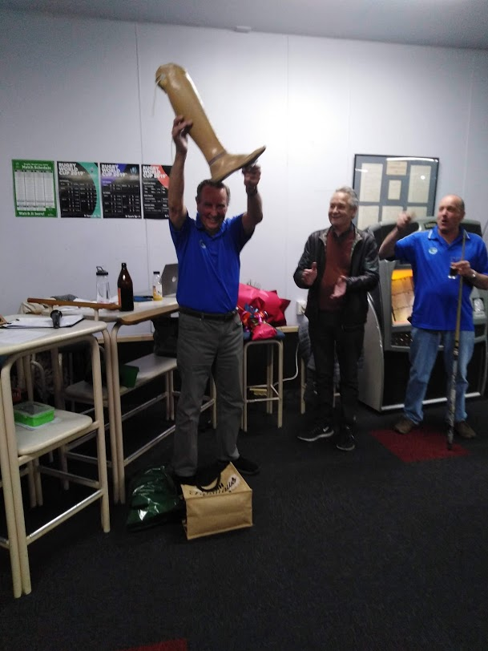
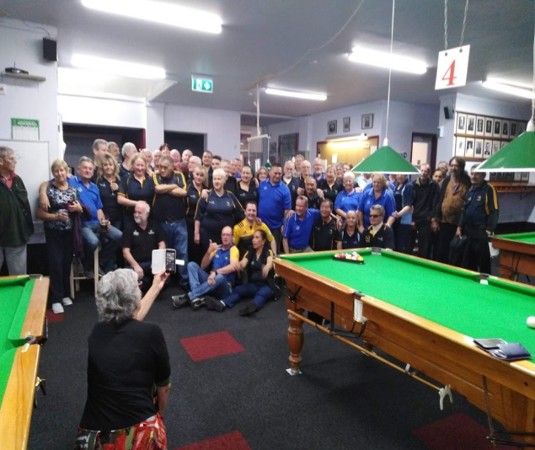
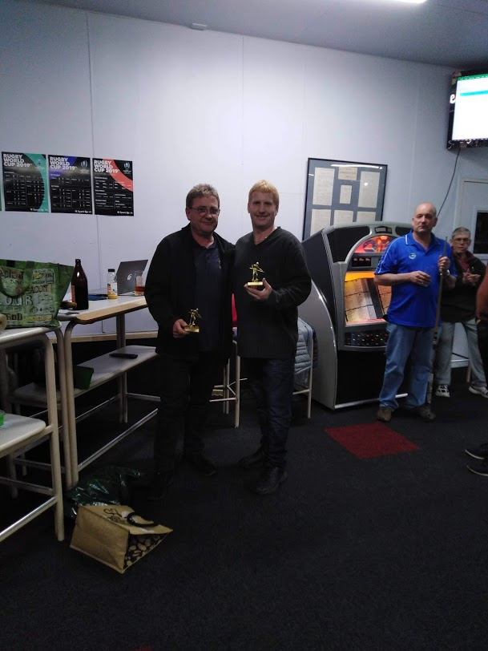

Jubilation for Levin after winning the
Lynn Scott Memorial Trophy
presented by Kathryn Scott
"Top Guns" for each team:
Petone - Chris Baker and
Levin - Phil Bucknall

Seniors Adjunct

On Wednesday 26th August 24 members boarded a bus to go to the Castlecliff Club in Wanganui. With our regular driver Peter now enjoying retired life and Harold on leave we were introduced to a new driver Geoff who did a great job.

We had morning tea when we arrived, even though we put them under pressure because we arrived earlier than they were expecting. While we were waiting for lunch the time was filled in by playing 5 games of Housie. Our members who were successful were Sarah with two Houses, David and Barbara with one House each.

After lunch and a slow start getting the bowls up and running we enjoyed our games. One team from here was well and truly beaten, didn’t even score a point. Maybe that could be put down to the fact that there were three Castlecliff players in the team. On a more positive note the team skipped by Betty won.

The pool was also played in good spirits, Lloyd a new member was top with five wins and Judy was second with 3 wins, John 2, and Roger 1. Well done to all that took part in the sports.

Sarah and Pat P won raffles. Afternoon tea was served and we left Castlecliff at 3.45pm for home, arriving back here at 5pm after an enjoyable day.

On the 9th October we played host to St Johns Club from Wanganui. 47 members made the journey down here. Once again there were bowls and pool played in good spirits. Some close games and as usual ended in a draw. Some may have doubts, but we play for the fellowship and fun and it is also good to meet new people.

I would like to say thank you to Bruce and the Bar Staff and also to Sidney and the Restaurant staff for catering for the guests with the lunch and afternoon tea.
Once again, thank you all.

We have Housie on the 16th and our trip to Petone is on the 23rd.

I would like to take this opportunity to wish Fred (our President) a speedy recovery.

Pat Perrin
Vice President

Indoor Bowls Adjunct

On Saturday 20th September Indoor Bowls entered a novice team to play in the Levin RSA Charity Gala. The team consisted of:

Anne & David Arnold
Graham Stock & Robyn Metge

Not ever playing as a team in a Gala before, out of five games they won four.

1st Game 8 - 4 2nd Game Loss 4 - 6
3rd Game 6 - 5 3rd Game 8 - 3
5th Game 10 – 1

One Team they came up against had two rep players, so we were over the moon to beat them 6 – 4.

Prizes were not awarded, as all proceeds went to St Johns, Levin

Fishing Adjunct

Morning fellow members;
Our adjunct has two final trips for the year, both from Seaview
Sunday 3rd November still has 12 spaces
Sunday 30th November still has 14 spaces

The cost: $160 per person

Membership fees of $20.00 will be due first week in December, please put this in an envelope with your name, club number and email address and give to Royce or Bob.

New fishers welcome.

We are booking trips for next year and will keep you advised.
The sooner you put your name down the sooner we can book the trips.

Please note we now have a dedicated noticeboard at the back of the Club sharing the Seniors & Golf board.

Regards
Bob & Royce

Clay Target Adjunct

Any shooters or club members that tick the Clay Target box who want to be involved please contact George Harper or Blue Taylor and we will help you get started at our Horowhenua Club grounds. You will need a gun or firearms licence and other gear which we will advise you of.

Cheers
Blue Taylor

Tertiary and Trades Scholarships

Applications for this year’s Tertiary and Trades Scholarships are now open and forms can be uplifted from the Office. Children and grandchildren of financial members are eligible. Applications close 29th November and decisions are usually made before year end.

Members Support Group – Nurse in Club

Remember we have the Nurse in the Club on the 1st Saturday of every month from 10.00am to 12 noon in the staff room annex, side foyer. Next visit 2nd November.

This is a no cost to members (free!!) visit to have blood pressure checks and a general health catch-up with a registered nurse. The Club funds this service for members.

Thanks so much for the volunteer organising group of John Beattie and John Craig and of course the Nurse. Obviously all consultations are private and information is confidential.

Emails and Mobile Numbers

We send our newsletter out each month to members who have listed their email addresses with us. If you wish to receive our newsletter via email please advise Jacqui in the office. Also, the same with the texts we send with specials and reminders – not getting them?? Please check we have your correct mobile number listed.

Foodbank

The Club Food Bank Annual Collection for the local food bank will start Monday 11th November. Please bring along your non-perishable food donation and drop off at the Food Bank Table in the Main Bar area. Please check expiry dates.

Thanks so much!!

Up Coming Events

Saturday 26th October Labour Weekend Pool Tournament
Saturday 26th October DJ Sam
Saturday 26th October All Blacks vs England 9pm
Sunday 27th October Labour Weekend Pool Tournament
Sunday 27th October DJ Sam
Sunday 24th November Country & Variety Music Club 1pm – 5pm
Monday 28th October Labour Weekend Pool Tournament
Saturday 2nd November Karaoke with Hendrix
Tuesday 5th November Melbourne Cup & Corporate Dinner
Saturday 8th November Ted Clements Darts Tournament
Sunday 10th November Ted Clements Darts Tournament
Saturday 16 November Double Blend Festival 6.30pm $20 per ticket
Sunday 17th November Opportunity Knocks Country Club 1pm – 5pm
Sunday 24th November Country & Variety Music Club 1pm – 5pm
Saturday 30th November Live Band: Make Believe

