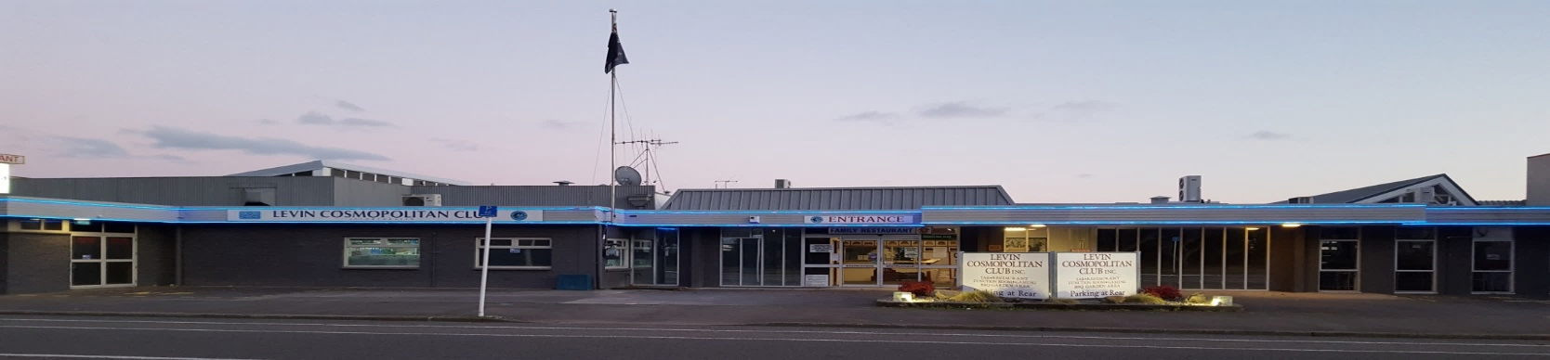
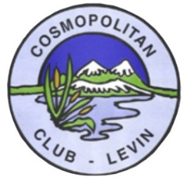
Levin Cosmopolitan Club Inc
December 2019 Newsletter

President’s Christmas Message

Together with the members of the Executive Committee, I extend warm Christmas Greetings to all members, the staff, and your families, with good wishes that 2020 and the years ahead will be healthy, happy and prosperous for us all.

I especially extend kindest thoughts to those who may have been unwell, and to those who sadly have experienced personal sorrow and grief during the year.

Please take care, stay safe, rest up and enjoy this Christmas time with loved ones.

Best wishes everyone for a Merry Christmas and a magnificent New Year.
Bruce McCarrison
President

Children’s Xmas Party

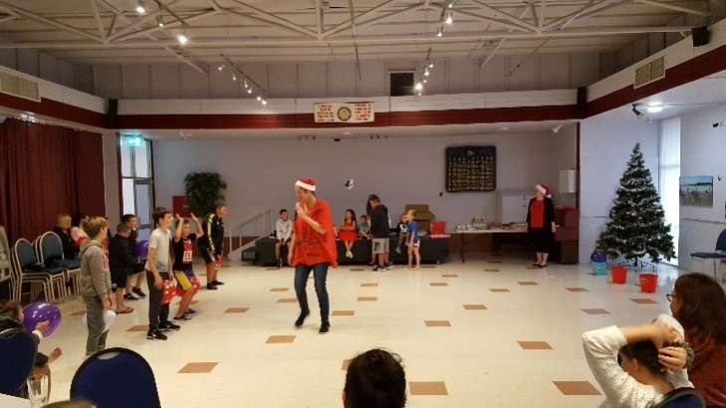
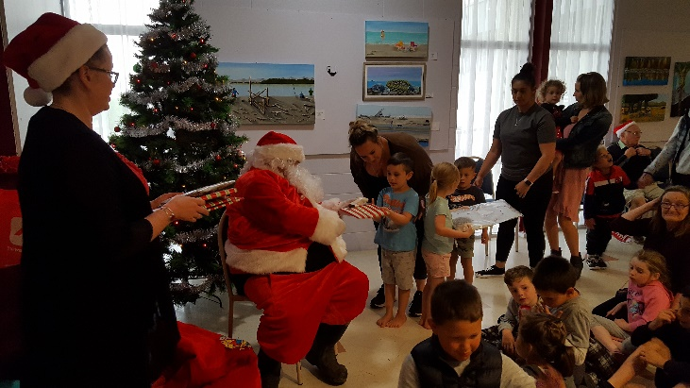
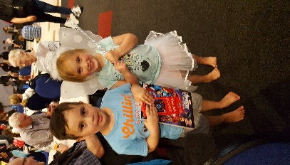
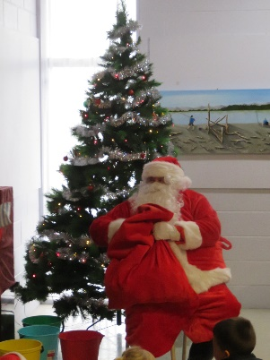
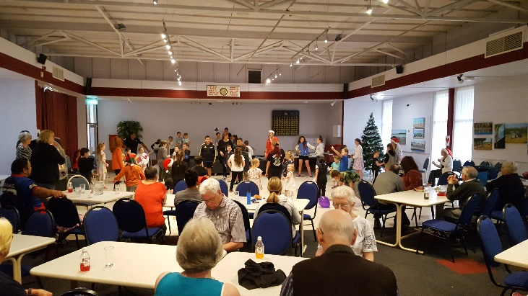
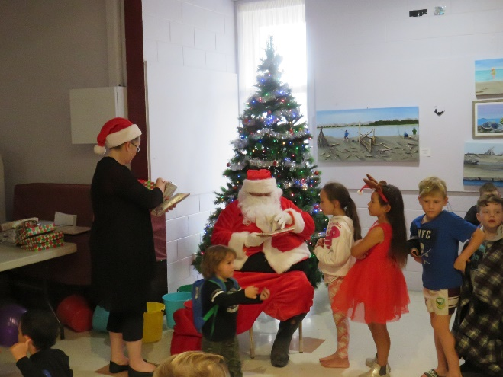
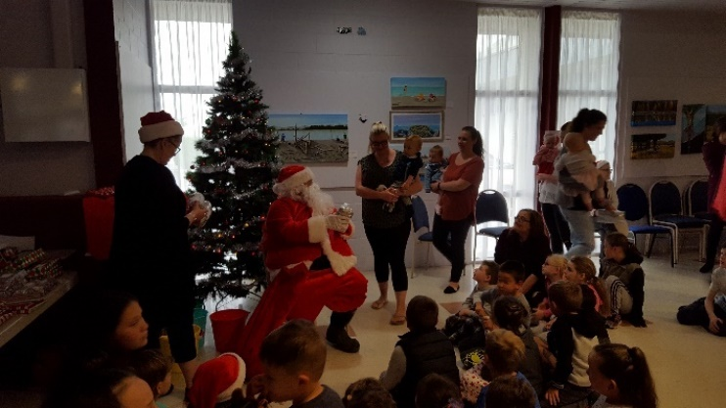
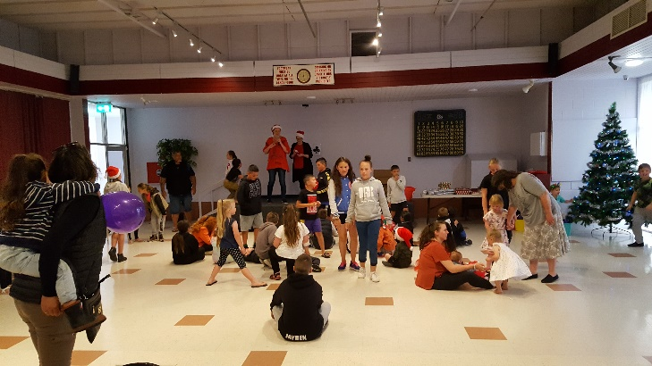
A big thank you to Lisa and Jo-Ann for organising the Kid’s Xmas Party, and for all the helpers on the day. The children (around 70 – 80 I’m told) I’m sure enjoyed themselves, with the fun games, food & drinks, and of course the arrival of the “Big Man Santa” himself, along with presents. Well done everyone.
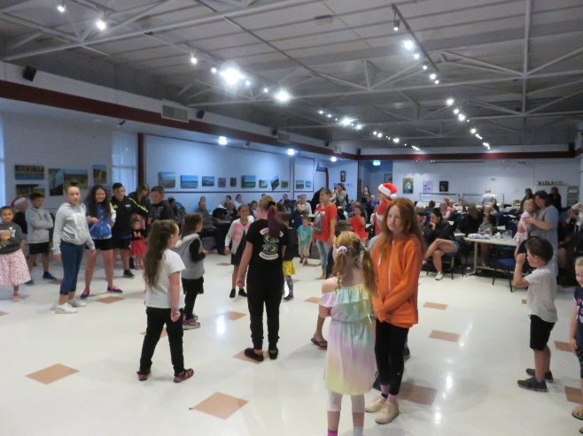

Christmas Raffle Results
This Photo by Unknown Author is licensed under CC BY-NC

Congratulations to the following winners of the Christmas Raffle:

Kim Williams 2 x Chickens
Bruce McCarrison $100 Cash
Jim Heald Christmas Ham
Dana Boleyn $50 Meal Voucher
Mike O’Malley 3 x Chickens
Stu Cleland Christmas Turkey
Felicity Apperley $50 Bar Tab
Steve Williams $100 Bar Tab
Archie Graham Christmas Turkey
Billie Paki Christmas Ham
Skippy Handy Heater
Yvonne King Christmas Hamper

Levin Cossie Ham & Chicken Pool Night – Prizewinners

Harvie Chicken
Margaret Ham
Michelle Chicken
Craig $20 Bar Tab & Ham
Rocky Chicken
Knox $20 Bar Tab & Ham
Billy Chicken
Dave Ham
Stan Ham
Woody Chicken

Remembrance
It is with great sadness that we farewell the following members:

Gregory (George) Skeet Member since July 2000
Craig Linton Member since July 2018
Dave Wishart Member since October 2006

Our thoughts and condolences go out to their families and friends.

Seniors Adjunct

2019 has come to an end, we had our final Club day on the 4th December. A novelty afternoon was organised for the indoor bowls. Thanks to Graeme, Ann and David for putting on a good afternoon with lots of fun. Prizes were awarded to the top four teams.

Housie was held with a good attendance. We’d like to thank Joon and Carole for giving up their time to call.

Our final event for the year will be our Christmas lunch being held on the 11th December.

We must thank Robyn for organising the indoor bowls so well and Heather for the Housie. Without their help these events would not be the success they are.

Our first day for 2020 will be the 15th January, which will also be our first Housie day for the year. Our barbeque will be on the 29th January. Details will follow in the New Year.

I would like to take this opportunity to wish all our members a Happy Holiday period. Take care of yourselves and we will see you in the New Year.

Pat Perrin
Seniors Vice President
This Photo by Unknown Author is licensed under CC BY-SA-NC

Outdoor Bowls Adjunct

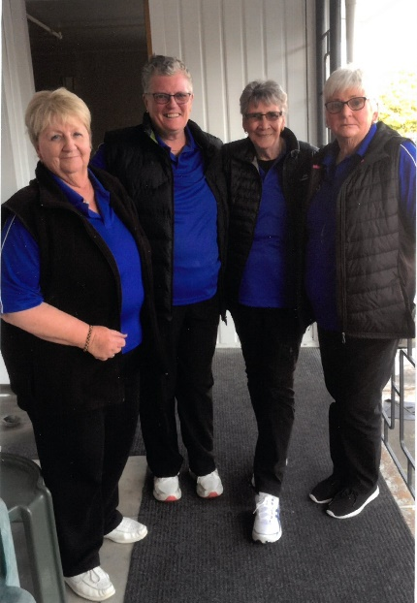

Bea Gray, Viv Hudson, Dot Collis & Babs Hirini

These ladies recently attended the Tokoroa Outdoor
Bowls Tournament. They were rained off the first day
and only managed one win and played in the
consolation and had one win. They enjoyed the trip and
playing in the tournament. Please note they are wearing
the new Cossie shirts.
Well done Ladies!!

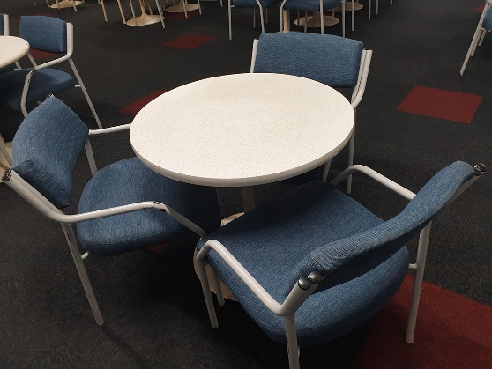
Table & Chairs For Sale

We still have available for purchase, sets of a small round table & 3 chairs – please see Jacqui in the office if you are interested in purchasing for $100.

Free Free

Anyone and Everyone is welcome to enjoy the contents of our takeaway shelf situated in the members lounge near to the start of the dart boards, which has a fantastic selection of donated DVD’s, CD’s and book for you to takeaway.

New Furniture

The club is looking amazing, if you haven’t been in for a while, come and see!!

We have new leaners and bar stools, as well as new tables and chairs for the members’ lounge as well as new tables and chairs in the Restaurant. Wow, so modern and very comfortable. We’ll be replacing the Hudson Room tables and chairs in the New Year.

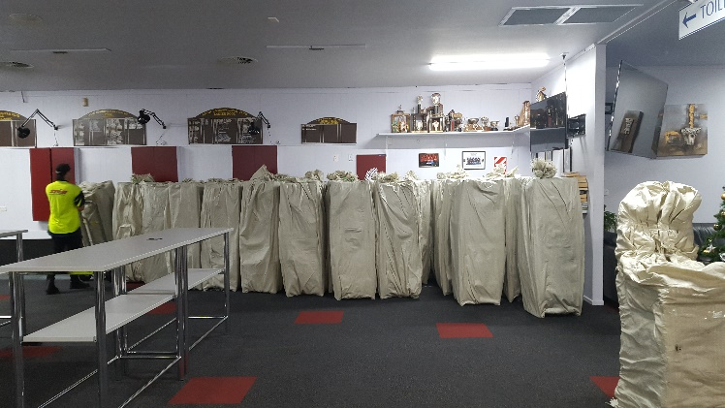
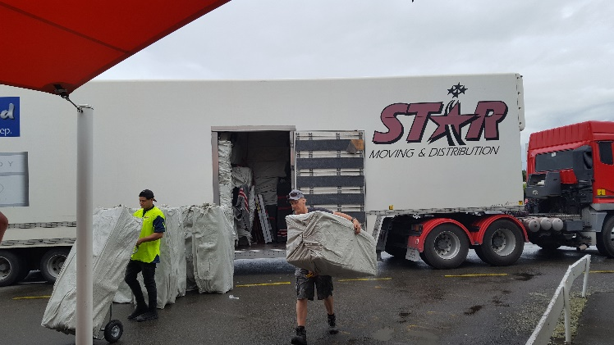
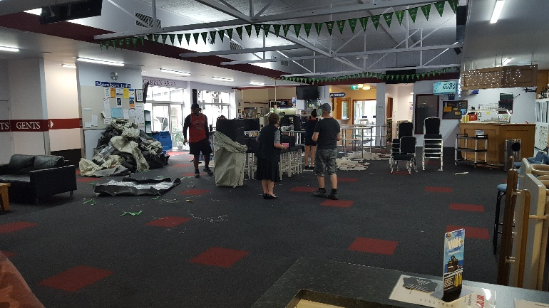
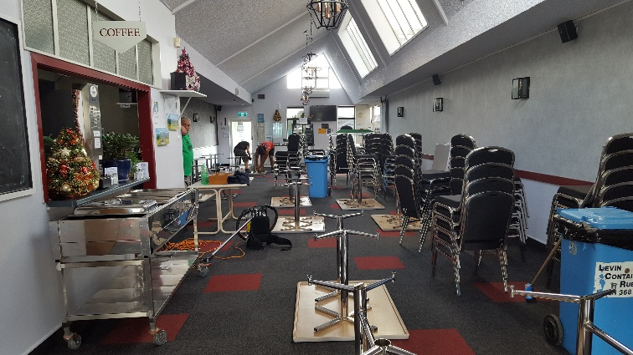
Please note: There is no reserving seats in the Club – it’s first in, first seated.

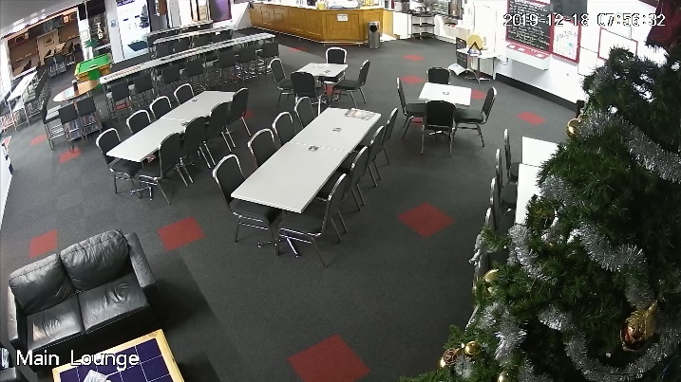
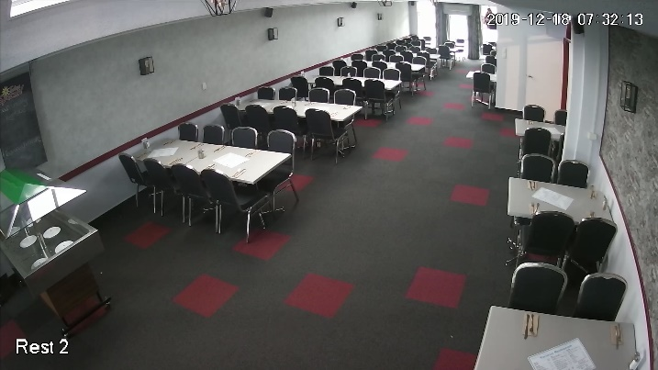

The Christmas spirit has arrived at the Cossie!
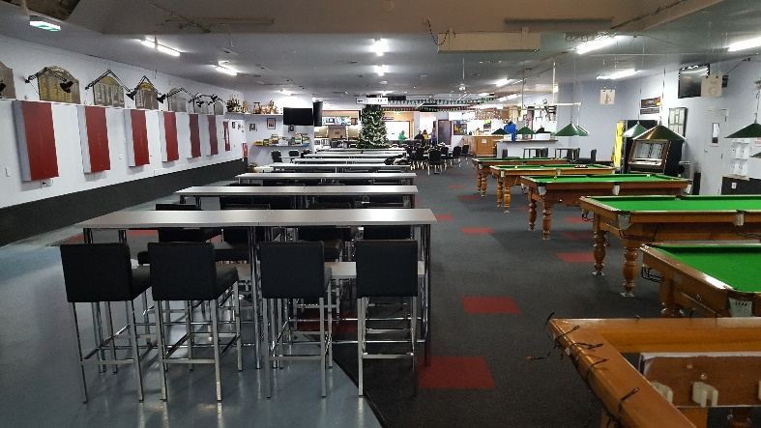
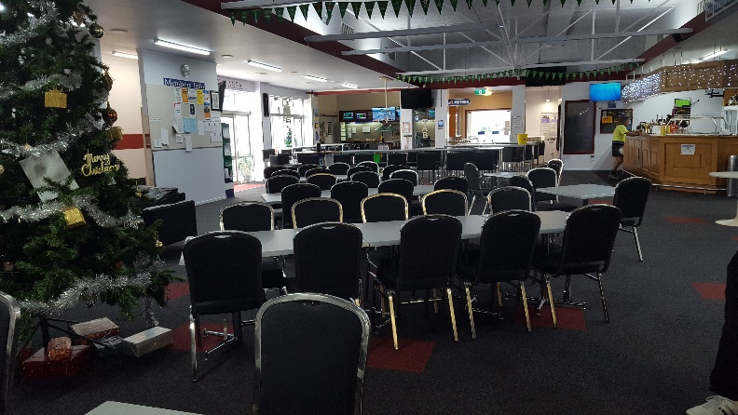

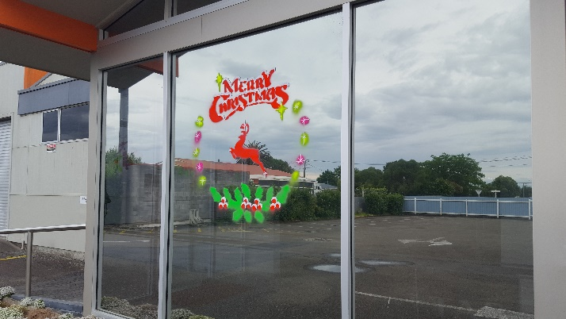
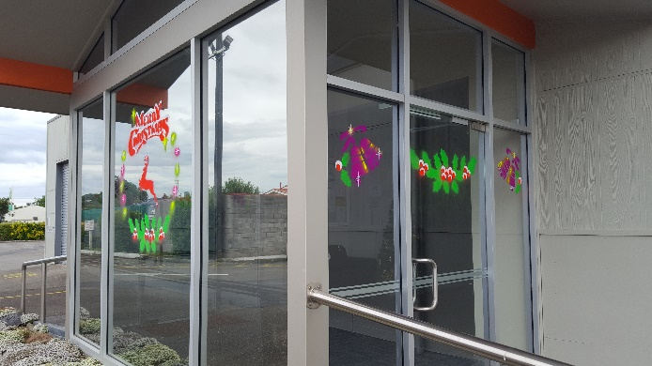
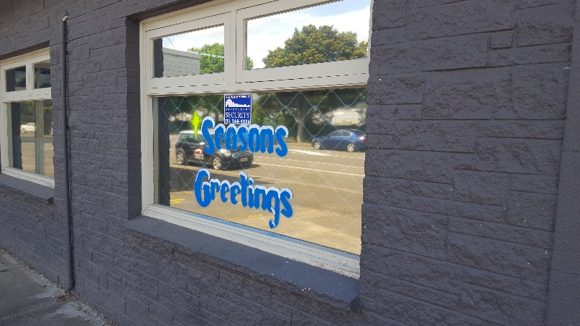

This Photo by Unknown Author is licensed under CC BY-NC-ND

Foodbank

We would just like to thank everyone who contributed to our Foodbank this year.
The collection was picked up on Friday 13th and they were very thankful to the members and Club for our generous donation.

(I apologise that I didn’t get a photo of our collection this year.)

Up Coming Events

Friday 20th Dec Karaoke with Trevor 8pm
Saturday 21st Dec Karaoke with Hendrix 8pm
Sunday 22nd Dec Country & Variety Music Club 1pm – 5pm
Saturday 28th Dec Live Band: Freedom Express (3 Pce) 9pm
Tuesday 31st Dec Live Band: Freedom Express (4 Pce) 9pm
Wednesday 1st Jan Double Blend (Geoff & Teresa) 1pm – 5pm
Saturday 4th January Karaoke with Hendrix 8pm
Saturday 11th January Band Jamm 6pm
Saturday 18th January Spiritual Fair 9am – 4pm
Saturday 25th January Fundraiser Entertainment Show 7.30pm $20 per ticket

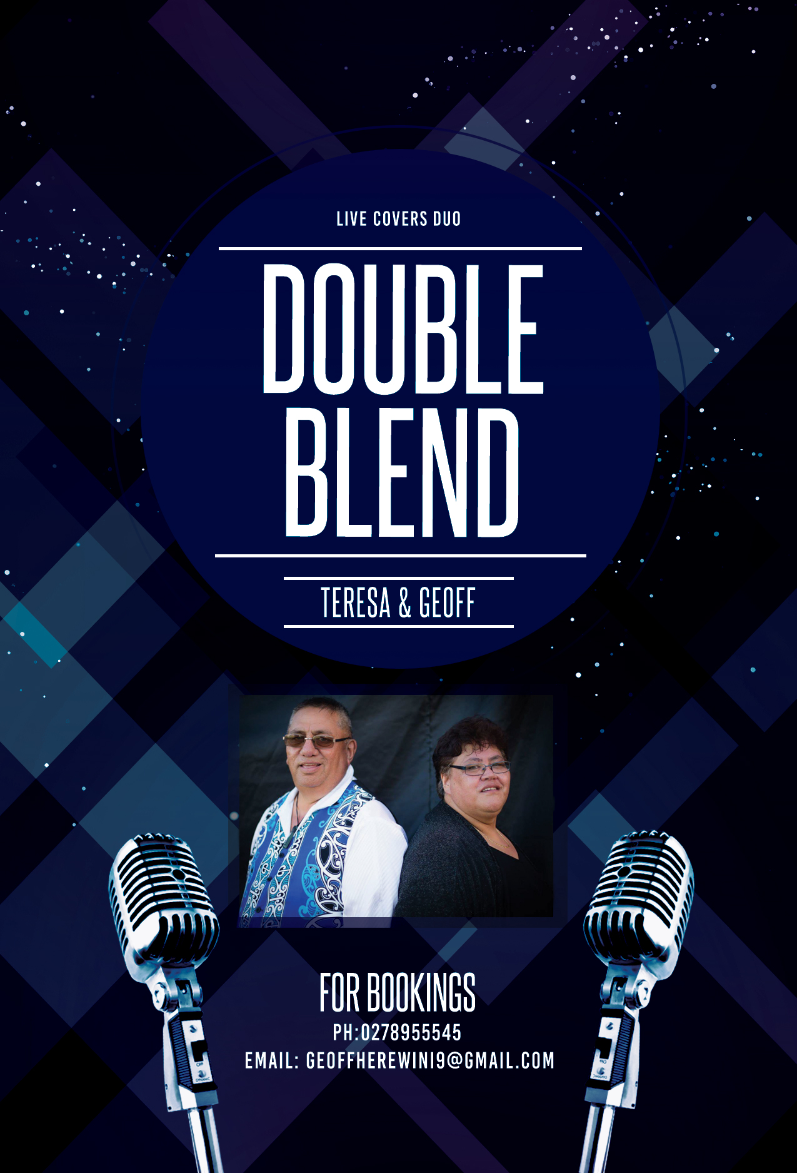

!!New Years Day!!
Levin Cosmopolitan Club 1pm to 5pm
Members, Affiliated Members & Guests Welcome

