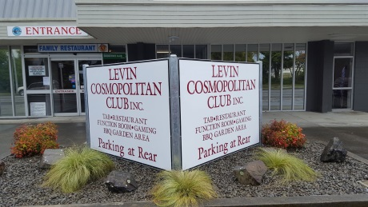
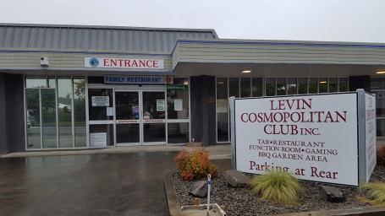

Levin Cosmopolitan Club Inc

May 2019 Newsletter

Hello everyone and welcome to the May 2019 issue of our monthly newsletter to members.

From the Treasurer’s desk is his report that our Club’s financial performance for this year so far is on track to be better than budget after a strong April with Easter trading being very good for us. Our year end is 31st July – just nine weeks away!

Our restaurant was particularly popular with members and their guests on Mother’s Day. This also is pleasing.

Concerning the restaurant, members can expect a new menu from around 4th June, when our Head Chef will introduce some changes, sneak preview of the new menu is on page 5.

The new ‘Smokers Zone” is now complete, thanks to all of those involved in its design, build and re-landscaping.

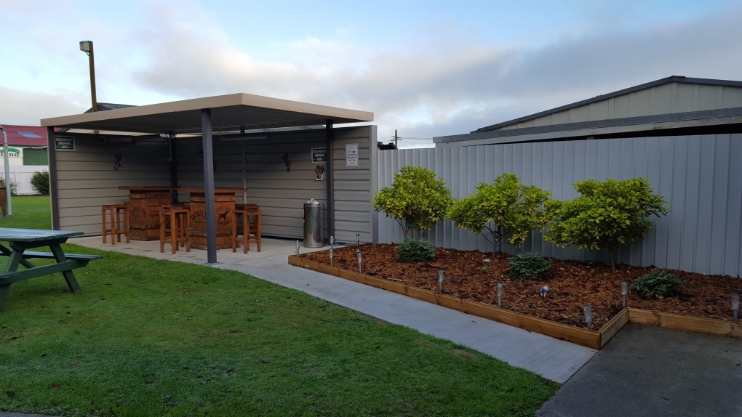

Club AGM
Our Club AGM will be Sunday 13th October 2019 – please put it in your diaries now.

Nominations for Life Membership will open 1st June and close 30th June for members who have provided extraordinary meritorious service at the Cossie Club. Application forms can be picked up from the Office during business hours.

Cheers everyone.

Nurse in Club

Every month the LCC Support Group funds a registered nurse to visit the Club.
This is an opportunity for you to have your blood pressure and sugar levels checked or discuss any other health problems you may be concerned about.
Diabetic tests are also available.
1st Saturday of every month
Time: 10.30am – 12.00noon
Held in the Club’s Staffroom

Joker Draw

Friday evenings between 6pm – 7pm
3 chances left to win $1,000
$1.00 per ticket – purchase at the Bar

Clay Target Adjunct

Any shooters or club members that tick the Clay Target box who want to be involved please contact George Harper or Blue Taylor and we will help you get started at our Horowhenua Club grounds. You will need a gun or firearms licence and other gear which we will advise you of.

Cheers
Blue Taylor

Open Cue Sports Adjunct

The Easter Classic for 2019 took place last month with mixed results for our LCC players. Only one qualifier for the Cup Section in Scott McLeod (beaten in Top 40).
In the Plate Section, Hape Royal played well to make the final but was beaten here by Nick Hinga. The female player to advance the furthest was Julie Wicks (Last 8 Plate Section).

May 11th we held a “Lynn Scott Memorial” day tournament and fun day at the Club. This was well attended with 34 entrants in the tournament and many more out of towners, particularly from Upper Hutt, enjoying the convivial arrangements on the day. The tournament was won by Steve Alderson who beat Dave Morris 2-1 in the final.
All in all it was a successful day with finger food and a few drinks provided and a lot of “Scotty” yarns being told.

There are a few other tournaments coming up including the North Island Championships, check the notice Board for details and have a go.

Lots of luck
Dave Morris

SENIORS ADJUNCT

Last issue I misreported our bowlers result against the visiting Porirua Club as a loss. I regret this but at the time I checked they were getting a hammering. Someone must have delivered a few stern words to them because they staged a remarkable come back to snatch a win in the end. Well done.

There was a trip away to the St Johns Club in Wanganui on 17th April. Competition was played on a friendly basis with the teams being mixed between the clubs which of course resulted in a draw.

We also had a trip away to Upper Hutt on the 8th of May where our bowlers drew and our Pool players continued with their winning ways. The Upper Hutt Pool players must have an afternoon siesta time scheduled because they seemed to disappear after lunch.
The lunch was delightful, roast meat with all the trimmings $12.00, and a lovely apple crumble for dessert at $3.00.

Regular Club days continue for the rest of May with Housie included on the 29th.
June 5th Petone will visit us to play for the “Johnny Walker Cup” and on June 19th we will be holding our Solstice Lunch here at the Club. See notice Board for details.

Good Health
Dave Morris
Remembrance

It is with great sadness that we have to farewell the following members:

Leisha Taplin Member since July 2005
Brent Horan Member since February 2014

Our thoughts and condolences go out to their families and friends.

Up Coming Events

Sunday 26th May Country & Variety Music Club 1pm – 5pm
Friday 31st May One Man Band 9pm
Saturday 8th June Karaoke with Hendrix
Sunday 16th June Opportunity Knocks Country Club 1pm – 5pm
Saturday 29th June Blues Band – Caramello’s 7pm Tickets $25
Sunday 30th June Country & Variety Music Club 1pm – 5pm
Saturday 13th July Karaoke with Hendrix

