Levin Cosmopolitan Club Inc

February/March 2019 Newsletter

Hi Members, time does seem to fly at times and February was just one of those months, here, then gone!!

This issue of our newsletter is therefore to cover both months, apologies to all.

Staff Changes

In our Restaurant Kitchen, Mr Ron Perera and Tracey Ornberg have resigned.
Our new Restaurant Manager is Mr Darren Davidson, a local resident and family man who has joined us from a Restaurant on the Kapiti Coast. Further, another new Chef will also join our kitchen staff shortly.

Carolin Borck has also joined us on our cleaning staff.

We welcome you all.

Changes at the Club

- The Club has been instructed by Mid Central Health to change the ‘smokers’ zone to make it compliant with relevant legislation. Accordingly we are required to construct a new sheltered area for this purpose. We will landscape and furbish the shelter and once completed, smoking in the existing area will be prohibited. The intention is to keep the existing area as an outdoor lounge but, again, smoking will no longer be permitted in this area. Kindly comply, as we have been advised to expect “spot audits” from those that set the rules!
- New floor carpet tiles have now been laid in the Hudson Room and nearby areas to the restaurant. This looks very smart and has pleasantly re-modernised the area. The partitioned wall between the restaurant dining room and Hudson Lounge has been rebuilt with increased internal insulation to reduce noise levels from either side to the other. This should markedly improve the enjoyment levels for all on either side of the divide.

- New front entrance signage is due to be installed during March.

- Our President Bruce McCarrison will be the Club’s delegate to the Annual New Zealand Clubs Conference to be held in Tauranga 20th to 24th March. Following last year’s conference Bruce and Vice President Mark returned armed with lots of good advice, ideas and information of what is happening in other Clubs and amongst other matters the Club purchased the instant food fryer in the Members Bar and coffee vending machine.

Attendance at this conference is for the potential good for all members and we thank Bruce for being available to attend this year. Safe travels Bruce.

- Members’ Exchange

On a glass shelf on the short divide wall by the dart boards, members have been donating items available to others for free use and return. Already surplus books, magazines and DVD’s have appeared. Enjoy.

- Come down to the club to celebrate St Patricks Day “Sunday 17th March”. Reduced Guinness price and other special treats – see ad further in newsletter.

- The LCC Easter Classic 8 Ball tournament to be held 19th – 21st April already has a full field of 80 players. Congrats and thanks to the organisers – a great credit to you all for the hard work done previous years, to be full up so early.

- The Club has some items of furniture/equipment for sale – see notices further in the newsletter – first in first served basis.

- Housekeeping – Membership Draws. Members are politely reminded that to be a winner of any of the Club Membership Draws, one must be in the Club house with your membership card at the time the draw is made. Thanks.

The Passing of Life Member – David Easton

David Easton aged 90 years has recently passed away. David was just the seventh member bestowed life membership status of our Club back in 1973.
(There have been 73 recipients to date).

We extend our sincerest sympathies to his family and friends.

Remembrance

It is with great sadness that we have also farewelled the following member recently:

Kay Nicholas Member since August 1994

Our thoughts and condolences go out to her family and friends.

Seniors Adjunct

The Seniors Adjunct barbeque took place on Wed 30th Jan in the outdoor barbeque/garden area of the club and was well attended. Sausages, burgers and salad were in plentiful supply.

A trip on Wed 20th Feb to Kaitoke Gardens and then Lake Ferry for a nice lunch was enjoyed by all who made the effort to attend.

Please see the notice board for details regarding further trips and sign up early for these enjoyable outings.

Upcoming events in March include a visit by Castlecliff Cossie on the 6th, for the usual rounds of competition in Bowls and Pool. The 13th is a normal club day which includes Housie, and on the 20th there may be a trip away to Palmerston North Cossie but this is yet to be confirmed.

Good Health and Happy New Year
Dave Morris

Open Cue Sports Adjunct

The first of our Club Champs tournaments to be played in 2019 took place on 10th Jan. This was the Masters Singles and was won by Al Wehipeihana who beat Hape Royal in the final.

A schedule of our local club champs with dates will be posted on the board shortly so you can pencil these into your calendar.

The Greater Wellington 8-Ball League draw for 2019 has been made and is on the board. This year Levin Cossie has three teams entered and the first round begins on
17th March.

Other upcoming tournaments are listed on the notice board and include the NI Champs at New Plymouth on 29th May to 2nd June. Test yourself out and have a go at this.
Thursday night club tournaments will continue until the Business House League starts sometime in April.

Lots of luck and keep practising
Dave Morris

Clay Target Adjunct

Any shooters or club members that tick the Clay Target box who want to be involved please contact George Harper or Blue Taylor and we will help you get started at our Horowhenua Club grounds. You will need a gun or firearms licence and other gear which we will advise you of.

Cheers
Blue Taylor

For Sale

18 x Bar Stools (ex Pokie Room)
$50.00 each

Please contact Bruce or
Jacqui in the Office

For Sale: Offers Please

Wooden Blinds (as shown)
5 x 1700w x 1600 drop
1 x 2200w x 1600 drop

2 x Roller Blinds – pale grey
1765w x 2120 drop

3 x Drum Holder/Tippers (only 1 with a drum included) 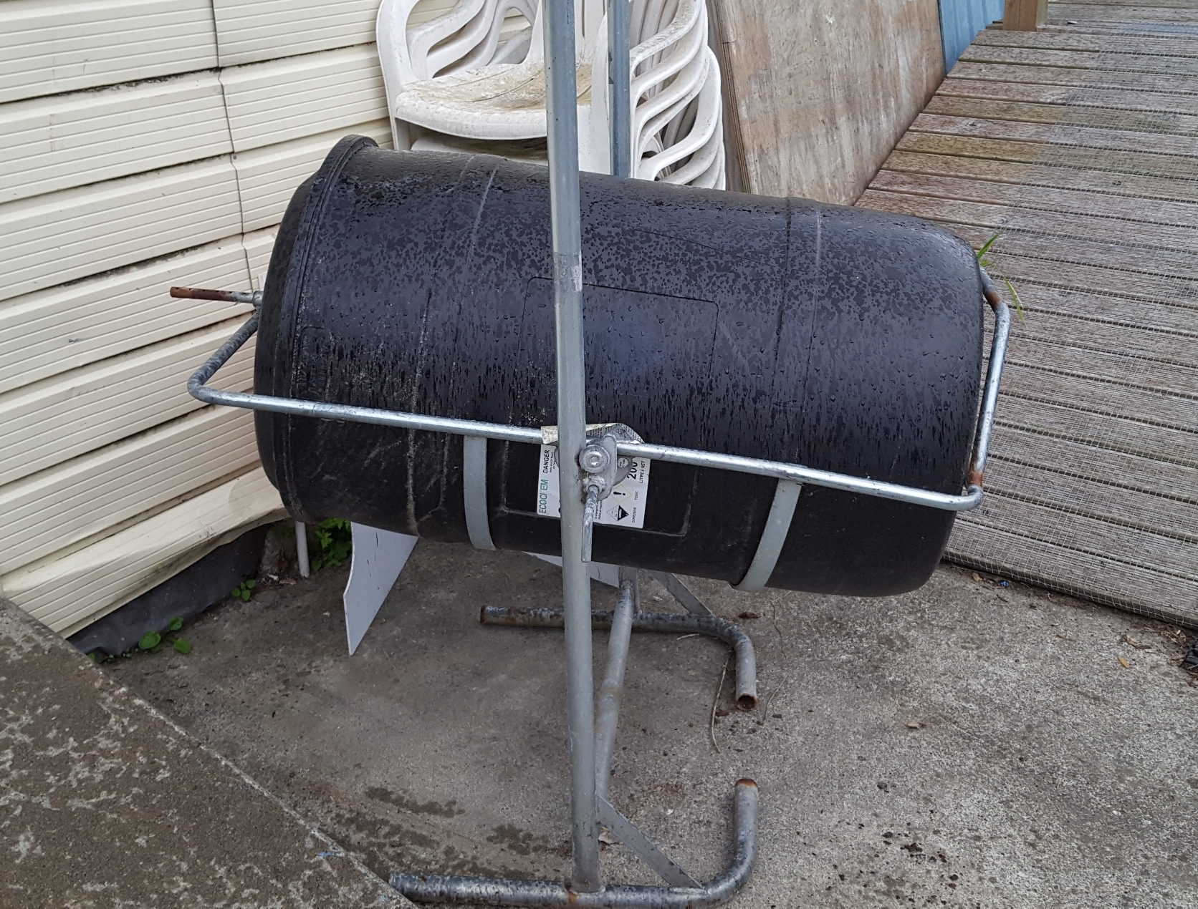
Please contact Bruce or
Jacqui in the Office

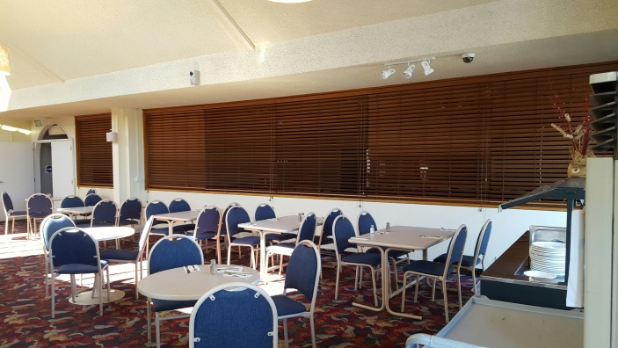

Up Coming Events

Sunday 17th March Opportunity Knocks Country Club 1pm – 5pm
Saturday 30th March Live Band: “Harmony Showdown”
Sunday 31st March Country & Variety Music Club 1pm – 5pm $4 entry
Saturday 13th April Karaoke with Hendrix
Friday 19th April Easter Classic 8 Ball Tournament
DJ Sam
Saturday 20th April Easter Classic 8 Ball Tournament
Sunday 21st April Easter Classic 8 Ball Tournament
Opportunity Knocks Country Club 1pm – 5pm

Saturday 27th April Live Band: “Still Undecided”
Sunday 28th April Country & Variety Music Club 1pm – 5pm $4 entry

St Patrick’s Day Specials
Sunday 17th March

Guinness:
$10.00 a jug Free Jukebox
$ 5.00 for 500mls Free Finger Foods
(No loyalty points) Free Pool Tables

Usual Super Saturday/Sunday Beer Specials on Tap Beer
Tui – Export Gold – DB Draught - Amstel

