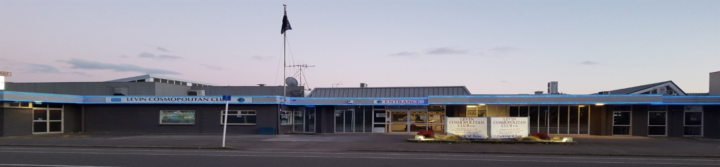
September 2019 Newsletter
Levin Cosmopolitan Club Inc

Hi everyone – only twelve weeks to go to Christmas Day and Santa Claus again – exciting for yourselves too??

Just an early notice, Christmas Day is a Wednesday this year and the Club will not be open that day, thereby allowing our staff to also enjoy the friendship and love of family and friends on that day. This means of course the Tararua Restaurant will also be closed. This early notice should give time to those who might have booked in the Club for Christmas Day dining to make reservations elsewhere as soon as. Thanks for your understanding.

October is the start of our busy busy period. Sunday October 13th 10am is our AGM, when the Executive Committee presents its report of our previous year’s activities and financial accounts. Election results are also announced. Come along, it’s a great day, some complimentary food, drinks and entertainment adds to the festivities.

Saturday 26th October to Monday 29th October is the annual Labour Weekend 8 Ball tournament and then Tuesday 5th November is our Melbourne Cup and Fashion in the Field Day. Lots to concentrate on going forward. Please mark your calendars now.

One of our many recent highlights is the resurgence of interest, positive feedback and improved profitability of our Tararua Restaurant. Thanks to all involved. The popularity is great, however we are asking members for some help please, that members and guests be punctual with your attendance at your reservation time. Our restaurant and kitchen is not large and work flows are seriously frustrated especially for later diners if the first groups are behind time! We are here to provide and offer maximum enjoyment and satisfaction with your dining experience, this will more easily be achieved if everyone is on time!

We are sure you will all receive this small plea for help with the goodwill as intended.

Happy clubbing everyone.

Members please note

The Oxford Street front entrance to the Club is now being closed and locked off at approximately 4pm (when the office closes). This is for health and safety reasons following a couple of recent undesirable incidents. Please use the entrances off the carpark at the back of the building. Thank you for your understanding.

Cheers Everyone.

Agenda - AGM

Voting Monday 30th September
To Friday 11th October

Counting 12th October
A.G.M. 13th October at 10am

Remembrance

It is with great sadness that we farewell the following members:

John Barrie Member since December 1993
George Harvey Member since October 1999

Our thoughts and condolences go out to their families and friends.

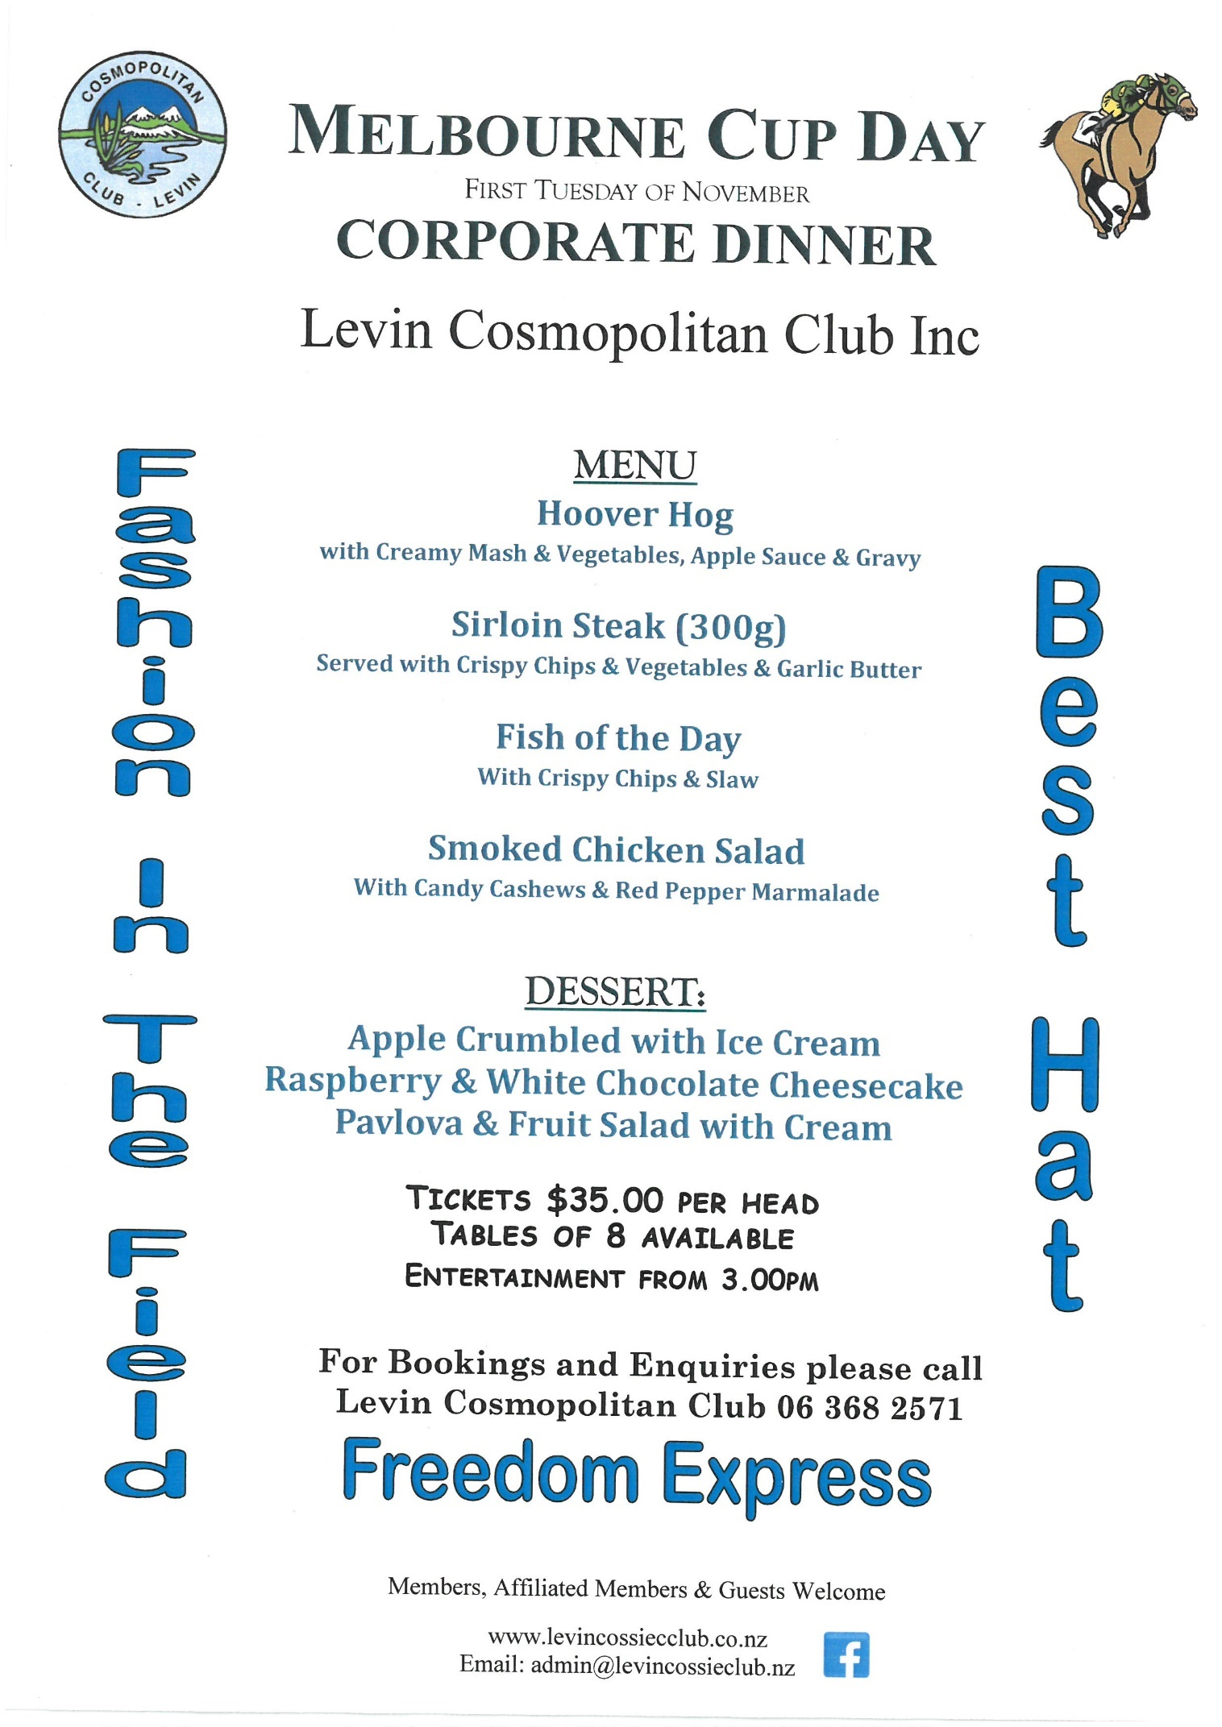

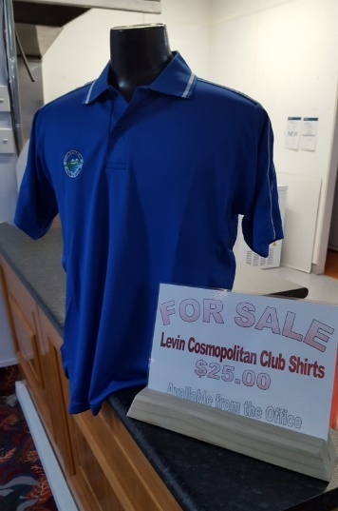
Club Shirts - $25.00

We have Cossie Club shirts available for purchase at $25.00. They have the Club Logo on them and are really nice quality. If you wish to purchase or have a look they are available from the Office.

Free Meal On Offer

Come along to the Cossie Club at lunchtimes 11am – 2pm Tuesday – Saturday and order off our menu 5 times and you will receive your 6th meal free, to the value of $16.00.

Open to the Public
Daily Lunch Special $10.00

We have:
Starters ranging in price from $8.00 - $14.00
Light Meals from $13.00 - $18.00
Main Meals from $22.00 - $28.00
A fabulous Dessert Menu for only $8.00

Plenty of carparking at the rear of the building.
A range of non-alcoholic drinks available to non-members.

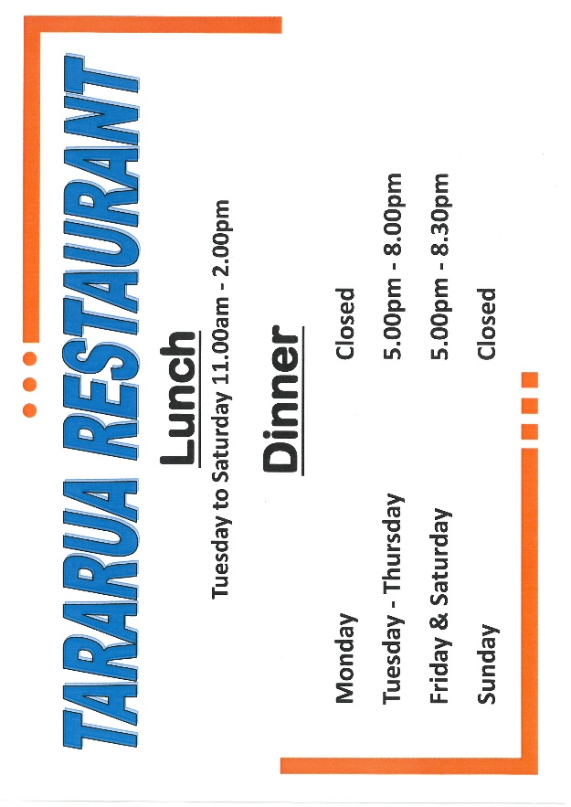
Starting Tuesday 1st October.

Open Cue Sports Adjunct

City Club Masters 2019 Singles
This tournament was played in Palmerston North on 7th and 8th of September and attracted a strong field of 72 players from the lower North Island.
There were 19 Levin Cosmopolitan Club members entered and 4 of them qualified to play in the main event:- Hape Royal, Dave Morris, Chris Bell and Jim Parkin.
Of these four – Hape reached the quarter finals of the Main event before losing and Dave went on to the semi-finals of the Main Flight event before being beaten.
The best of the rest were:- Les Taylor, Runner up in the Plate, and in the Plate Flight event we had both finalists – Warren Laing running out the winner and Greg Creighton was Runner up.

Adjunct Notice Board
A schedule of LCC tournaments still to come in 2019 has been posted on our notice board alongside other news and results. There is also a notice, calling for names, regarding our coming Inter-Adjunct tournament with Petone on Saturday 19th October.
This will be held here at our Club and we’ll need about 30 players willing to play all day.

A BBQ lunch will be available around 12-30pm and the prize giving will take place at 6-30pm.

Please peruse these notices whenever you come into the Club so as to keep abreast of what’s happening in our Adjunct.

Lots of luck
Dave Morris

Clay Target Adjunct

Any shooters or club members that tick the Clay Target box who want to be involved please contact George Harper or Blue Taylor and we will help you get started at our Horowhenua Club grounds. You will need a gun or firearms licence and other gear which we will advise you of.

Cheers
Blue Taylor

Seniors Adjunct

The Seniors AGM was held on Wednesday 11th September at 1-30pm.
All those nominated for election were elected unopposed. Those people were:-

President – Fred Carrick
Secretary – Irene Good
Treasurer – Robert Hammond

Committee:-
Peg Rickson, Judy Kitchener, Heather Turner

Fred Carrick was also deservedly elected as a life member of the Seniors Adjunct.

A lot of General Business discussion centred around the problem of how to break even on the bus trips. Currently, with members pulling out of the trips in the week before departure, the members that do go are not numerous enough to cover the cost of the empty seats.
It was proposed and passed that the cost per seat would rise from $15.00 to $20.00 and once committed, there would be no refund if you failed to go.

The meeting closed with a nice afternoon tea provided by the Senior’s Adjunct.

Bus Trips
The next trip away will be to Castle Cliff on Thursday 26th September, and the next visit to our club will be by the St. Johns Club on Wednesday 2nd October.

We will also be making a trip to the Petone Working Men’s Club to play for the Johnny Walker cup on Wednesday 23rd October.

Membership
Please be aware that to participate in the Senior’s Adjunct activities which take place every Wednesday from 11am until 3pm, you need to be a financial member of the Adjunct.
The activities are only for Senior’s Adjunct members and include Bowls, Pool, Cards and Housie, yes! you need to be a Senior’s Adjunct member to take part in the Housie as well.

For those of you who have not yet paid your subscription, see our new Treasurer, Robert Hammond, who will be only too pleased to sign you up.

There will be a list of financial members posted on the Seniors notice Board to refer to.

Remember !!!! No Pay = No Play.

Good Health
Dave Morris

Fishing Adjunct

We have a fishing trips coming up on the 29th September 2019 & 12th October 2019.
If you are interested in going on the trip or joining our adjunct please contact Bob Bell on 027 442 8188, or add your name to the list on the main noticeboard.

Rugby World Cup

The Club is able to show all the Rugby World Cup Games, come down Sunday 6th October to watch the All Blacks play Namibia at 5pm. There are posters around the Club showing dates and times of all the games.

Up Coming Events

Saturday 28th September Live Band: Muse Bros
Sunday 29th September Country & Variety Music Club 1pm – 5pm
Saturday 12th October Karaoke with Hendrix
Sunday 13th October Club A.G.M. – 10am
Saturday 26th October Labour Weekend Pool Tournament
Saturday 26th October DJ Sam
Sunday 27th October Labour Weekend Pool Tournament
Sunday 27th October DJ Sam
Monday 28th October Labour Weekend Pool Tournament
Saturday 2nd November Karaoke with Hendrix
Tuesday 5th November Melbourne Cup & Corporate Dinner
Saturday 8th November Ted Clements Darts Tournament
Sunday 10th November Ted Clements Darts Tournament
Sunday 17th November Opportunity Knocks Country Club 1pm – 5pm
Sunday 24th November Country & Variety Music Club 1pm – 5pm
Saturday 30th November Live Band: Make Believe

ATTENTION: MEMBERS

Late October, early November we will be replacing all our Bar Leaners, Tables & Chairs and Stools in the main bar and restaurant.

We would like to offer Club members first opportunity to purchase any of these items before we open them up to the public to purchase.

We will be placing a list and amounts of goods for sale on the notice board and in the newsletter. They will be sold on first in, first sold!

Terms and conditions of sale:
- All goods must be paid for prior to uplifting
- All goods to be picked up on the day which we confirm they will be available
- No Refunds

Items for Sale:

16 x Bar Leaners & 3 Stools $130.00 per set
5 x Small Leaners (no stools) $ 50.00 each
23 x Small Round Tables & 3 Chairs $100.00 per set
17 x Restaurant Tables & 4 Chairs $150.00 per set

We will be placing a sheet on the noticeboard where you will need to PRINT your name and phone contact details on, along with what you would like to purchase. You will also need to pay at the office for any goods ordered.

Any questions please see me or Jacqui in the office.

Bruce McCarrison
PRESIDENT

