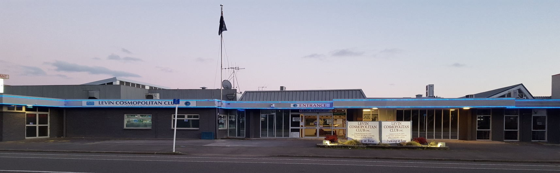
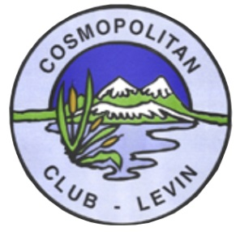
June 2019 Newsletter
Levin Cosmopolitan Club Inc
Hi everyone and we would like to think everyone is enjoying this very mild winter so far, well during daylight anyway when the sun is beaming down but after sunset is a different story. So pop down to the Club anytime as our staff are keeping the inside temperature toasty warm for us. Enjoy the many sporting tournaments on the TV’s and generally socialise with all.

Remember Club membership draw is every Tuesday evening and you must be at the Club to claim your prize (potentially $1,000) if your membership number is drawn.

We certainly commend to everyone to try our Chef’s fantastic and tasty “Clubmade” pies, available in the pie warmer by the Bar most days. Always freshly baked in small quantities so please don’t get too disappointed if your first or second choice is already sold out.

Reminder to all to use up all your accumulated loyalty points before 31/7, when all unused points expire. Points can be redeemed on food and beverage purchases only
– sorry TAB, Gaming and Raffle Ticket purchases do not qualify.

In the interim keep safe and warm and perhaps I will see you at the pie warmer.

Cheers

Club AGM
Our Club AGM will be Sunday 13th October 2019 – please put it in your diaries now.

Clay Target Adjunct

The Levin Cossie Clay Target Team travelled to Te Kuiti for the North Island Single Rise Championships. The members were Blue Taylor, Doug Turner, George Harper, Steve O’Hara, Casey Woods, Arron Snee and Dianne Baird.

The 1st Event – 25 Target Single Rise – two possibles shot:
Blue Taylor and Doug Turner
Blue 4th and Doug 5th both taking placings in the Individual.

2nd Event – North Island. Single Rise Championship and Individual – No Placings

3rd Event – North Island Point Score Championship and Individual
Doug Turner shot possible 75 points - Placed 2nd

3rd Event – Mac McKenzie Memorial Team Match
Levin team of Blue, Doug, George, Steve and Casey were victorious over Waitomo on 119 points over 118 points.

A big well done to our team, a great day’s shooting. We still need more local shooters to turn out for the events. Let me know if you wish to travel to these shoots. The next one is November 16th in Bay of Plenty.

Any shooters or club members that tick the Clay Target box who want to be involved please contact George Harper or Blue Taylor and we will help you get started at our Horowhenua Club grounds. You will need a gun or firearms licence and other gear which we will advise you of.

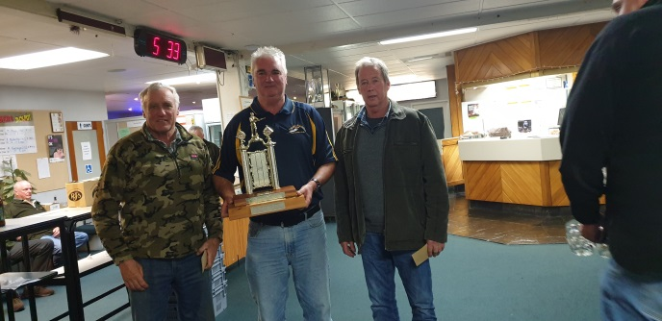
Cheers
Blue Taylor

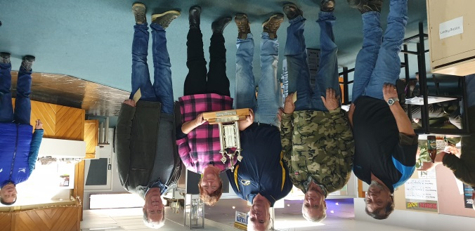

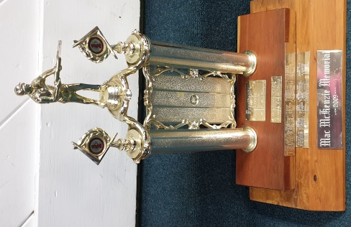

Open Cue Sports Adjunct

Dates for our 8-Ball Club champs are as follows:-
Sun – 14 July Open Singles (to commence after the AGM)
Sun – 11 August Mike Doyle Memorial - Open Singles
Sun – 29 Sept Open Pairs
Sat – 23 Nov. Maurie Bang Cup – Mixed Pairs (Only one player needs to be a LCC member)

Registration for all the above events is from 9am to 9-30am.
Other tournament dates will be announced later in the year.

Annual General Meeting (AGM)
Cue Sports Adjunct AGM will be held in the Hudson Room on Sunday 14th July at
9-45am.
A list calling for committee nominations will be placed on the Board shortly.
If you have some ideas and want to help in running the Adjunct smoothly, please place your name on the nominees list accordingly.

Club Shirts
Get your Club shirts from the office now at $25.00 each - you can’t go wrong.

Castlecliff Trip
A trip to Castlecliff was undertaken on Saturday 8th June to play 8-Ball, this resulted in a win to Levin and a really nice outing. Castlecliff also provided a very generous lunch at no cost to us. Further trips will be planned.

Business House League
Eight weeks gone and five more to go before the Top and Bottom split into separate sections. It’s tight between some teams on the cusp of making the Top seven but still time to shine in the last five matches.

Lots of luck
Dave Morris
Seniors Adjunct

June 5th Petone visited us to play for the “Johnny Walker Cup” which we retained.
The 8-Ballers had a good day with a 29 to 21 victory and the bowlers managed a draw, don’t be sceptical, really a draw 15-15.

June 19th we held our Solstice Lunch here at the Club with a good turnout. There was a choice of roast beef or roast pork with all the trimmings followed by dessert.
I’ve only heard good comments about how nice it was so things are looking up in the restaurant and with the $17.00 roast pork meal a staple on the menu, strong demand for a quality, reasonably priced meal, should continue.

July 10th we expect a visit by Palmerston North Cossie to play 8-Ball and Bowls.

July 25th will see us visit Porirua to defend the Kiwi Trophy. I’ve become quite attached to the little Kiwi so let’s send a strong team so as not to lose the little fellow.

Have you seen our new Club shirts?. Lovely shirts and a really great price at $25.00.
Available now from the office, let’s start looking like a Club with everyone decked out in the same smart Club shirts instead of the mixture we have now.

Don’t forget Subs are due by the 31st July.

Good Health
Dave Morris

Golf Adjunct

Special price of $10.00 per round at Levin Golf Club – all Cossie members welcome. No official handicap required.

Next Game: 7th July 2019 – Tee off 11.00am

Following Game: 21st July – Tee off 11.00am

For further details please contact:
John Saulbrey 368 1637
Bruce Kerse 367 2116

Remembrance

It is with great sadness that we have to farewell the following members:
Wayne Glover Member since February 2018
Mary Kirk Member since November 1984 (Life Member)

Our thoughts and condolences go out to their family and friends.

IMPORTANT NOTICE

Just a reminder to all members of the Club.

You must not sign people into the Club that you do not know!!

It is against the law to do so. This puts not only the Club at risk of closure of up to 7 days and an instant fine, but also puts our staff at risk of receiving an instant fine once the sale of alcohol has taken place.

You, as a member, may think you are doing good for the Club but actually you are putting us all at risk. So please ensure you only sign in people you know (friends and family) and ensure you stay with them in the Club during the whole duration of their visit.

Thank you,
Lisa Beddis
Bar Manager

Loyalty Points

A reminder that your loyalty points will expire on 31st July 2019 when we roll over for our new financial year. Please ensure you redeem any points earnt for food or drink before this date.

Caramello’s Blues Show

This show was held on Saturday 29th June and it was very successful and a very enjoyable evening.
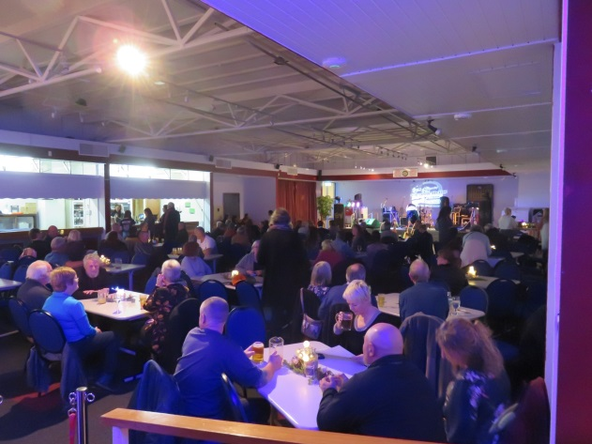
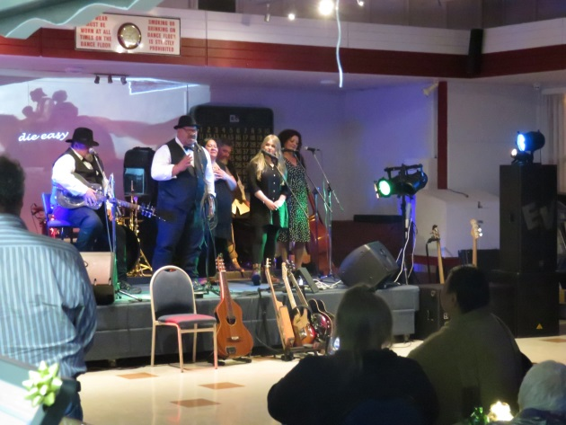

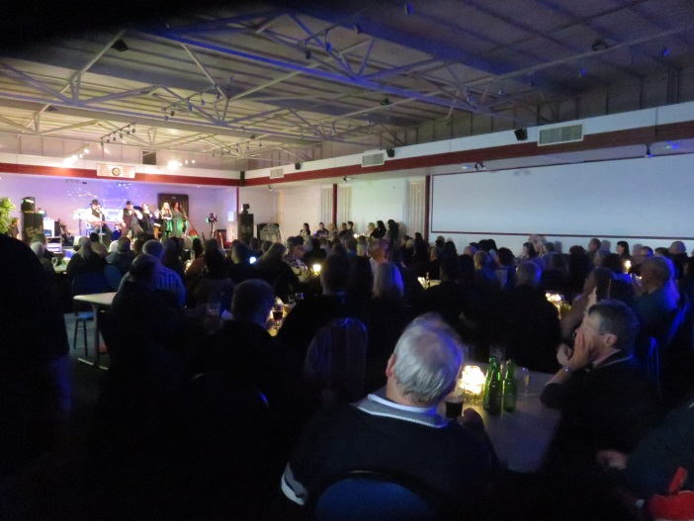

Up Coming Events

Saturday 13th July Karaoke with Hendrix
Saturday 20th July Spiritual Fair 10am – 4pm (1 to 1 readings)
Sunday 21st July Opportunity Knocks Country Club 1pm – 5pm
Saturday 27th July Ainslie’s Album Fundraiser 1pm – 4.30pm $15
Saturday 27th July Live Band: “Just in Time”
Sunday 28th July Country & Variety Music Club 1pm – 5pm
Saturday 10th August Karaoke with Hendrix
Sunday 18th August Opportunity Knocks Country Club 1pm – 5pm
Sunday 25th August Country & Variety Music Club 1pm – 5pm
Saturday 31st August Live Band: “Just Us Duo”

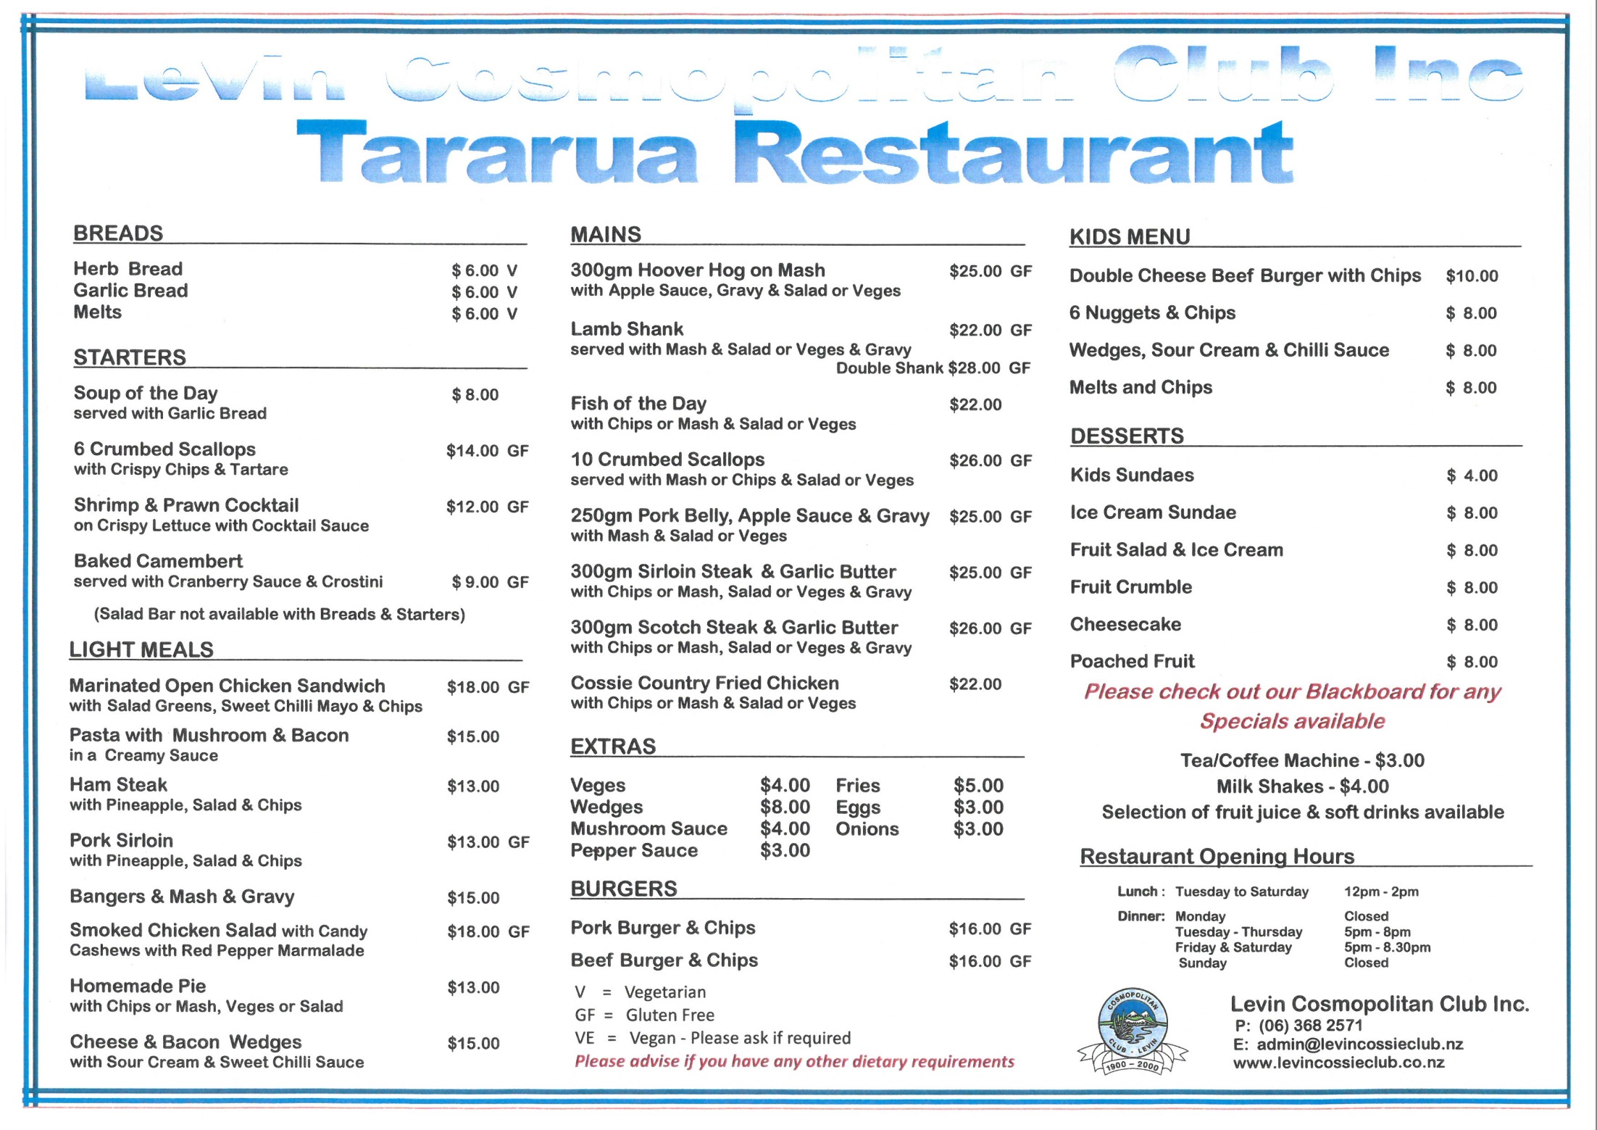
Club Activities & Contacts

Clay Target - Blue Taylor 368 8904
George Harper 368 4960

Darts - Wednesdays Dave Pitihira 368 9304

Fishing - Garry Ferguson 027 246 8957

Golf - John Saulbrey 368 1637
Bruce Kerse 367 2116

Housie - Thursday evenings
Games start @ 7.30pm

Indoor Bowls - Tuesday evenings Fred Carrick 367 0311

Line Dancing - Monday @ 5pm Chrissy Taylor 367 8028
Wednesday @ 6pm Marjorie Empson 368 0696
LCC Members - Ross Tulloch 368 7834
Support Group John Craig 368 4840
Diane McAulay 368 6568
John Beattie 367 3133

Open Cue Sports - Thursday evenings Cherie Blanche 021 1610 820

Outdoor Bowls - Danny Madden 368 3547 Viv Hudson 368 7191

Quiz Night - Fridays Darryl Small

Senior Members - Wednesdays @ 11am Fred Carrick 367 0311
Annette August 368 0835

